Interoperability test “cim for system development and operations” 2012

Appendix A: INFORMATION ON TOOLS TESTED/used IN THE IOP
3 September 2012
Final Version

European Network of
Transmission System Operators
for Electricity
Contents
6 Appendix A: Information on tools tested/used in the IOP 3
6.1 CimConteXtor 3
6.2 Cimphony 4
6.3 CIMSpy EE/CIMdesk 7
6.4 Convergence 2.5 10
6.5 CRESO 14
6.6 DIgSILENT PowerFactory 21
6.7 e-terrasource - a Power System Modeler 25
6.8 EUROSTAG® 28
6.9 Integral 7 (FGH) 31
6.10 ISPEN 35
6.11 NEPLAN® 39
6.12 Network Manager SCADA/EMS 47
6.13 OPC FOUNDATION OPC UA BASED INTERFACE FOR CIM 51
6.14 SPIRA 57
6.15 SYNDIS 62
6.16 TNA 65
6.17 UIB Adapter for use with the OSIsoft PI System 71
6.18 Utility Integration Bus (UIB) SISCO Model Store (SMS) 74

Appendix A: Information on tools tested/used in the IOP

CimConteXtor

Vendor presentation
Zamiren is a small consultant and engineering company which offers services related to TC57/CIM and TC57/IEC61850 environment.
Zamiren
18 bis quai Pierre Brossolette
94340 Joinville-le-Pont
France
Tel : +33148854006
Mail: contact@zamiren.fr

Tool description
CimConteXtor is an open source add-in to “Sparx Systems Enterprise Architect” (EA) product.
It extends EA functionalities by providing a framework that allows creation and management of UML profiles "based on" existing UML models, and helps you to do these profiles according to a rigorous methodology based on a «layered» approach:
CimConteXtor first target is to build profiles (i.e restricted subset of the model) based on the Common Information Model (CIM), which is the standard information model defined by the International Electrotechnical Commission for the Power System domain. But, in fact, it could be used to do any profiles based on a UML model.
CimConteXtor web site: http://www.cimcontextor.net

Other tools linked to CimConteXtor
CimConteXtor is coming with companions’ add-in tools to deal with generation of specific artifacts using language like XML or RDF. CimSyntaxGen is one of them and generate schemas according to IEC standard like TC 57 XML NDR draft or TC 57 WG 13 IEC 61970 part 501 (RDFS).

Expected CIM functionalities
CimConteXtor and its companions will evolve according to reflect any decisions made by the various TC57 working groups.

Cimphony

Vendor presentation
Open Grid Systems Ltd. is a consultancy and software company based in Glasgow, UK providing services to the electrical power industry focussed on model-driven software engineering, open standards and cutting-edge technologies. Open Grid Systems provides expertise in the areas of data management, information modelling, data transformation, data-exchange technologies, visualisation and power system network analysis software. We utilise the power of open standards and model-driven architectures to provide modern, scalable solutions to the challenges faced by utilities in the smart-grid enabled world.

Tool description
Cimphony began as a research project in the University of Strathclyde and in its previous incarnation was utilised at a number of EPRI and UCA-sponsored interoperability tests for model validation. The new version is fully re-engineered, based on open-source software and utilises the OSGi modular system and an Eclipse-based UI to provide a multi-platform framework for data management and power system analysis tools.
The core Cimphony modules provide model-independent services for:
- Data management and editing
- OCL-driven validation
- Model-driven transformation
- Distributed database persistence
- Graphical visualisation
- Geographical export using KML
The model-driven architecture allows support for new formats and data models to be added to Cimphony without requiring the core frameworks to be altered. Support is already in-place for a number of data models including established open standards such as CIM (multiple versions including ENTSO-E profiles), MultiSpeak and IEC61850; or proprietary formats such as PSS®E (v30-32) and extended standard models such as that used at ERCOT. Transformation and validation services using these models are defined using OMG standard languages allowing the rapid development of transformation mappings between data models.
Multiple resources can be combined in dynamic working sets, supporting the ENTSO-E model multiple profiles and authority set concepts. The workspace provides gives the user the ability to integrate, export, substitute, add and remove individual resources on an ad-hoc basis from their dynamic working set.
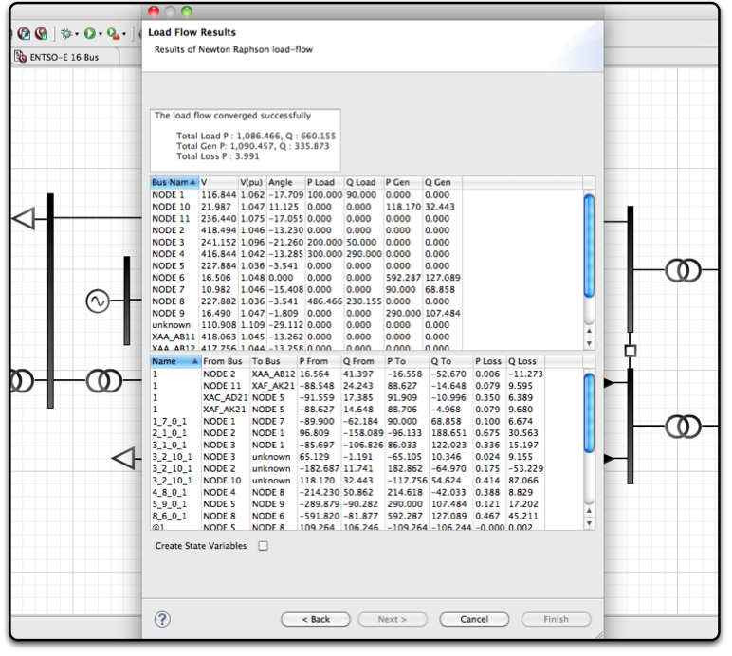
Load Flow Results
In addition to the model management service, Cimphony provides CIM and power-system specific functionality including the ability to execute load-flow simulations on balanced, three-phase models using the Jacobi load-flow engine, and supports the export of these results using the IEC 61970-456/ENTSO-E CIM XML State Variable profiles. In addition a topology processor module allows operational models compliant with IEC 61970-452 to be imported and a topology file (as defined by IEC 61970-456) to be created and exported thus allowing an ENTSO-E compatible planning model to be generated from an operational CPSM model.
The Cimphony components can be deployed in a number of environments: an application library for integration with other Java applications; web-services; command-line application; web-based UI; distributed, cloud-computing environments; or as a native, rich-client UI utilising Eclipse frameworks.
The rich-client UI can be run on Windows, Linux or OS X. As well as providing a UI for the validation, transformation, import/export and difference model functions, it provides an infinite-tree model-driven browser and graphical editor with preliminary support for single-line diagram creation and editing in a common UI (with support for multiple data-models).
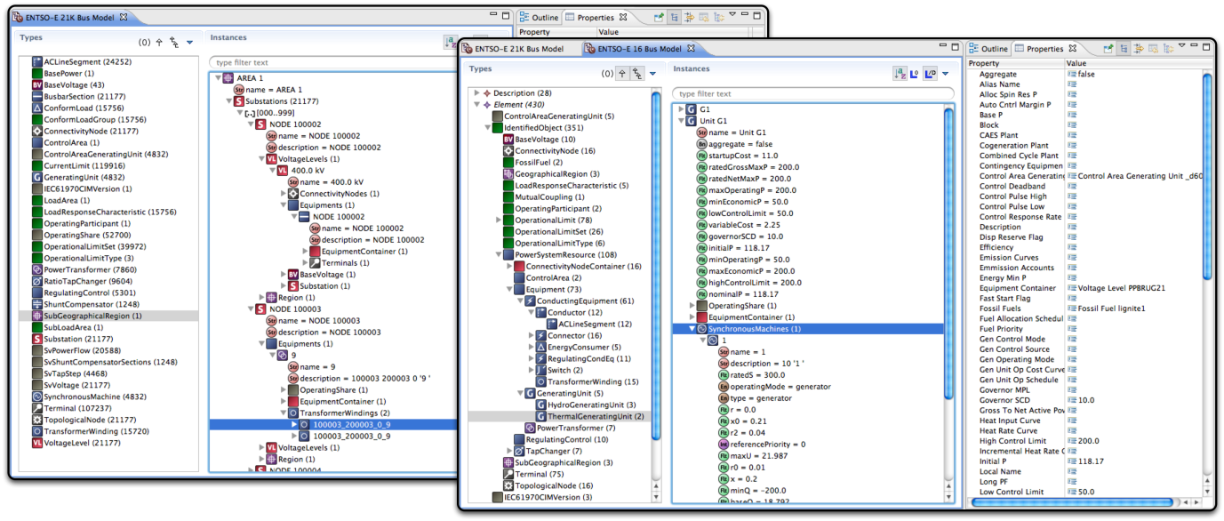
Browser Interface with different hierarchical views
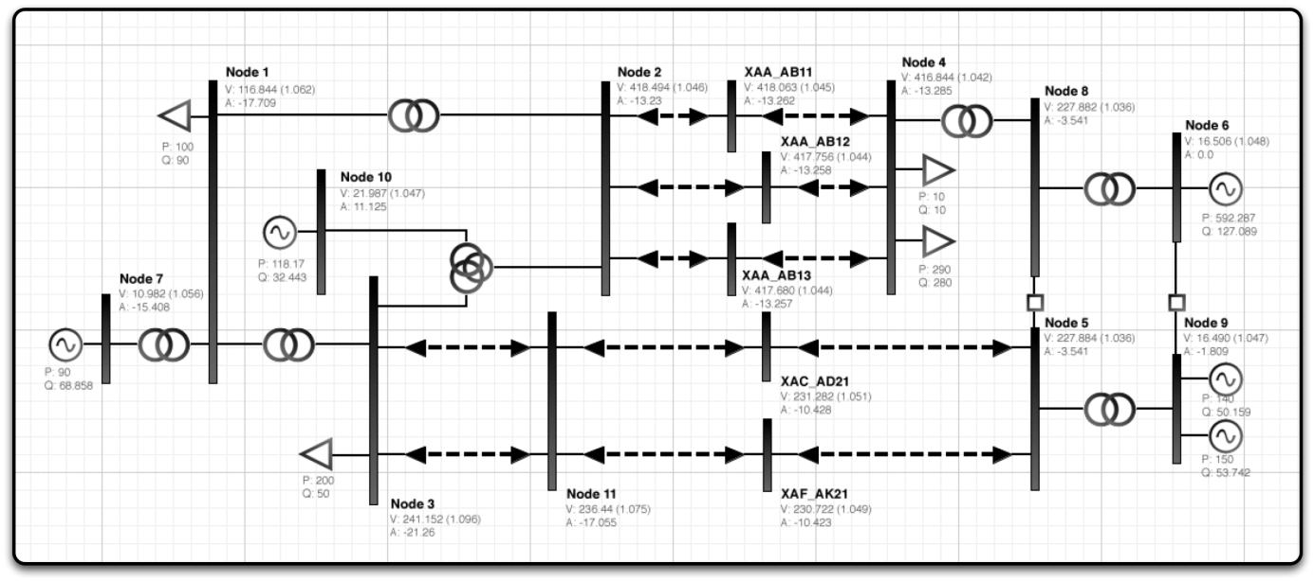
Graphical Editor acting as a Single Line Diagram editor

Other tools linked to Cimphony
The core Cimphony modules for RDF import/export, profile support, validation, transformation and difference model generation/merging can be utilised for building custom model-driven interfaces and applications and has been utilised to create stand-alone transformation and validation applications.
Jacobi is the load-flow engine used within Cimphony, part of a suite of services that can be integrated to provide:
- Newton-Raphson and Fast Decoupled load-flow engines
- Optimal Power Flow
- Contingency Analysis
- Steady State Estimator
These tools are being integrated with the graphical viewer to provide a rich UI for visualising simulation results.
An unbalanced distribution network simulator is currently under development, which will be integrated into Cimphony to support simulation of distribution models. This will enhance the existing model-management and geographical visualisation export support for the IEC 619768-13 Common Distribution Power System Model (CDPSM) profile.

Expected CIM functionalities
Cimphony currently supports the core functionality required for managing the exchange of CIM data including support for CIM v10-14 (plus v15 draft) and associated modules:
- Full dataset RDF XML import/export
- Incremental dataset Difference Model RDF XML import/export/generation and merging
- Profiled importing and exporting and transparent inter-dataset dependencies
- ENTSO-E Profiles and model authority set support
- IEC 61970-452/456 CPSM Profile
- IEC 61968-13 CDPSM Profile
- IEC 61970-552 Header model support including dependency verification
- Preliminary support for draft IEC 61970-453 CIM Graphics Exchange standard
Open Grid Systems was one of six vendors that participated in the EPRI CPSM Interoperability test in Knoxville, Tennessee (June 2010) and Cimphony will continue to support the latest versions of the CIM in addition to other IEC and industry standards. Open Grid Systems is committed to continuing involvement with future interoperability tests while supporting the international standards process through active participation at the working group level.

CIMSpy EE/CIMdesk

Vendor presentation
Power Info LLC (www.powerinfo.us) is an independent consulting firm specializing in providing the standard-based solutions to electric utilities in the power industry. Our area of expertise includes standard-based enterprise application integration, CIM-based model exchange and information management, and power grid visualization.

Tool description
CIMSpy Enterprise Edition (CIMSpy EE) is a CIM-based tool framework designed to address a wide range of common information engineering requirements in the power industry.
Architecturally, CIMSpy EE is a distributed Web-based enterprise application containing three tiers: a Web browser based user interface (UI), an application server, and a CIM-compliant data repository. Functionally it includes a set of infrastructure and application modules designed to significantly reduce the engineering effort required to exchange and manage information in a utility environment. Based on the open architecture and the infrastructure support of the CIMSpy EE framework, new solutions can be quickly built and deployed to address the changing business requirements in various CIM-based application areas, ranging from model exchange to power system modelling and grid visualization.
For example Power Info LLC has delivered the CIM data engineering solution kit (CIMdesk) to the European Network of Transmission System Operators for Electricity (ENTSO-E) and its Transmission System Operator (TSO) members. CIMdesk was built on the top of CIMSpy EE. It was customized to support the ENTSO-E/CICIM profile and model merging business processes specifically designed to support the model exchange among ENTSO-E and its TSO members.
More specifically, CIMdesk is designed to provide an integrated data engineering environment in support of CIM-based model exchange. Users can load reality-based exchanged CIM/XML files into the tool and perform various data engineering functionalities, including model browsing, visualization, validation, editing, merging, partitioning, and applying incremental update. The engineered models can be further exported into various formats such as XML or CSV, ready to be consumed by other CIM-compliant information infrastructures.

- CIM/XML
- CIM/CSV

- Full
- Partial
- Incremental

Incremental Updating
Merging/ Partitioning
Browsing
Editing
Visualization
Filtering

- CIM/XML
- CIM/CSV

- Full
- Partial
- Incremental

In-Memory
RDF Database
Comparison
Validation
Importer
Exporter
CIM data engineering solution kits (CIMdesk)

One of the key design goals of CIMSpy EE tool framework is supporting CIM visualization. Information visualization has proved to be one of the effective techniques for meeting the emerging business requirements in today's power industry. It involves visual representation of large-scale collections of information and use of graphical techniques to help people understand and analyze the data. The existing commercial power system visualization tools require the visualizations to be manually-built and restrict the visualization process to follow a limited number of pre-defined patterns created by human designers, thus hindering users’ ability to discover. CIMSpy EE adopts a different approach. Built upon CIM, CIMSpy EE yields the power of visualization to users. A variety of data-driven techniques are applied to auto-generate the high-quality visualization displays, enabling users to visualize the power system’s physical and electrical configurations at various levels and from different perspectives. Furthermore, by leveraging the latest-and-greatest information visualization technologies and open industry standards, CIMSpy EE is aimed to deliver a rich user experience and provide a standard-based visualization solution that can be seamlessly integrated with the existing utility information infrastructure.
CIMSpy visualization was designed to support multiple business functions in an electric utility environment. Some of the identified business functions that have been put into practical use include:
- Facilitating power system model exchange - Utilities that exchange their operational/planning models can leverage this tool to understand different configurations of the power system in their neighboring utilities.
- Interpretation of analytical result - Analytical results, including planning, operational, and marketing, etc., can be intuitively displayed on top of the generated network diagram to facilitate interpretation.
- Speeding up operator display building - For EMS display designers, this tool can perform majority of the tedious work for them. All they need to do is simply adjusting the auto-generated diagrams for better look-and-feel and then fixing the adjusted to create operator displays.
- Assisting application development - A user-driven graphical tool will significantly facilitate development and debugging of network applications.
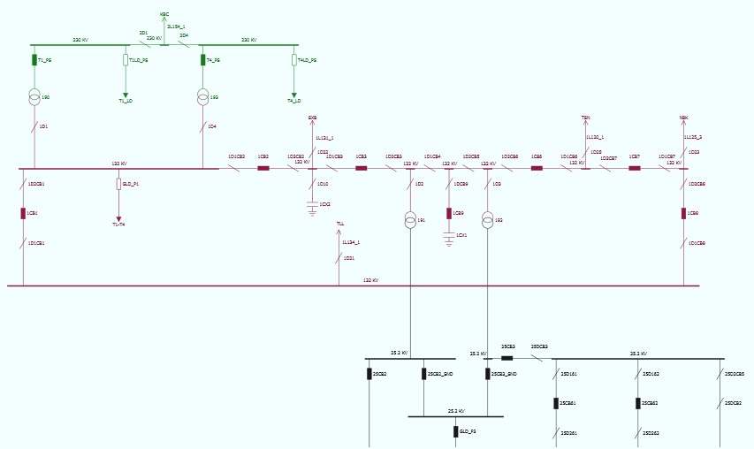

In May 2011, US Department of Energy (DOE) awarded Power Info LLC an innovation grant in support of the continuous research on data-driven visualization of power grid,

Other tools linked to the CIMCpy EE
In addition to CIMSpy EE/CIMdesk, Power Info LLC also provides a set of CIM-based data engineering components that can be embedded into other CIM compliant information infrastructure, including high-performance CIM/XML parsing, station diagram auto-generation, operational to planning model transformation, and model merging and equivalencing, etc.

Expected CIM functionalities
The following features and enhancements have been planned for the future versions of CIMSpy EE:
- Supporting CIM Schematic Layouts Standard (IEC 61970-453)
- Supporting IEC 61970-456 and interfacing with EMS/SCADA to enhance situational awareness in a grid control centre environment.
- Supporting visualization of bulk power system operating conditions over wide geographical region.

Convergence 2.5

Developer presentation
RTE is the operator of the French electricity transmission system. It is a public service company which operates, maintains and develops the high and very high voltage network.
With the largest network in Europe, consisting of more than 100,000 km of lines ranging from 63 to 400 kV and 46 cross-border connections, RTE is a central player in the construction of the European electricity community.
www.rte-france.com/

Tool description
Convergence is the energy management system (EMS) developed by RTE, the French transmission system operator. It has been designed for users from both grid operation and grid development divisions.
Convergence is based on a client-server model. This allows centralization of computational processors and shared databases on the server side, and thus only requires a light interface on the client side.
Main figures about Convergence 2.5:
- Handles over 350 users in total, 250 simultaneously,
- Handles over 7000 nodes networks.
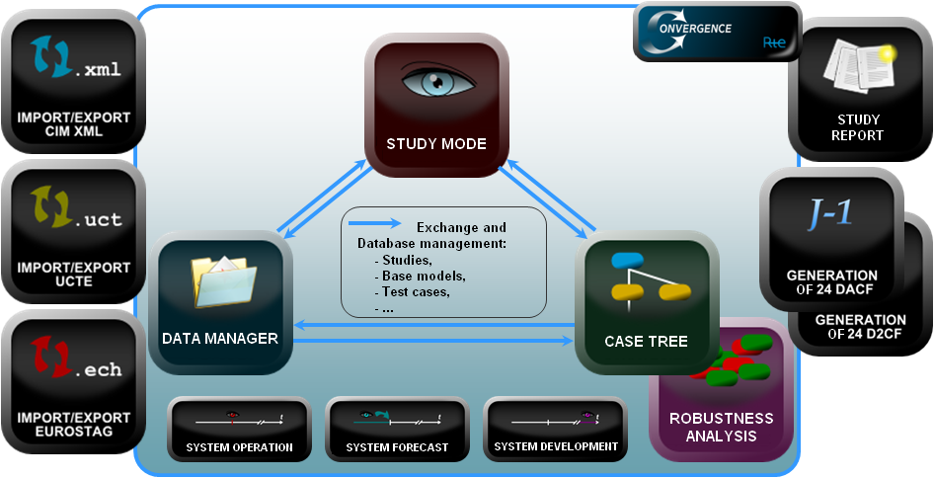
Overview of Convergence’s modes and functionalities
Convergence has three central modes:
- Study mode,
- Case tree mode,
- Data manager mode.

Study mode
In study mode, the user starts by loading a network base case with a fixed structure. The user can then perform a study on the network base case by doing the following:
- Run computation modules:
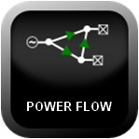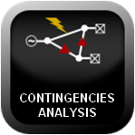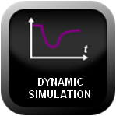

Available modules are:
  - State Estimator,
  - Power Flow,
  - Contingencies Analysis,
  - Sensitivities of Active Flows to Active Injections (in DC approximation),
  - Three-phase Short Circuit Analysis (symmetrical and dissymmetrical),
  - Dynamic Voltage Security Analysis (ASTRE tools with QSS: Quasi Steady-State simulation)
  - Initialization of Generations,
  - Initialization of Voltages (OPF: Optimal Power Flow),
  - Analysis of Power Flow divergence (OPF).
- Display different graphic representations:
  - A simplified map of the area described in network case with aggregated flows on borders between sub areas,
  - A full map of the network with different levels of details depending on the zoom level (cluttering/de-cluttering),
  - User-defined sub area map,
  - Substation representation.
From these graphic representations, the user has access to most of the functions: explore, edit data, browse results, and launch computations.

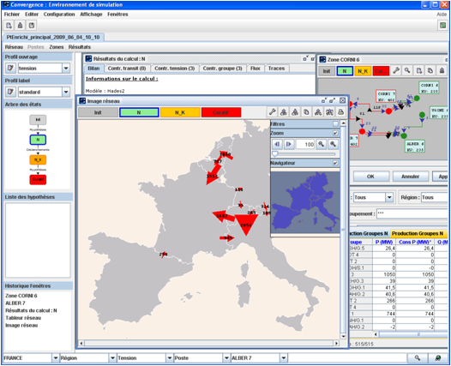
Screenshot from the Study mode: centre: simplified map; top right: user-defined sub area map; bottom right: customized results table
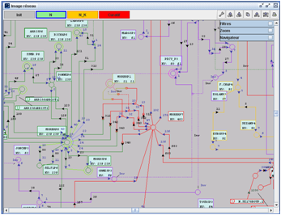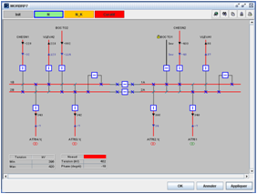
Screenshot from the Study mode: left: map of the network; right: substation representation
- Compare network states,
- Apply efficiently data modification (generation, load, topology…).

Two other kinds of user interfaces are provided to edit data and analyze results:
- User-defined tables allow browsing computation results and browse/edit data of network case,
- Specific tables or curves allow to display specific results using cross reference or in synthetic way and to enter some specific data.
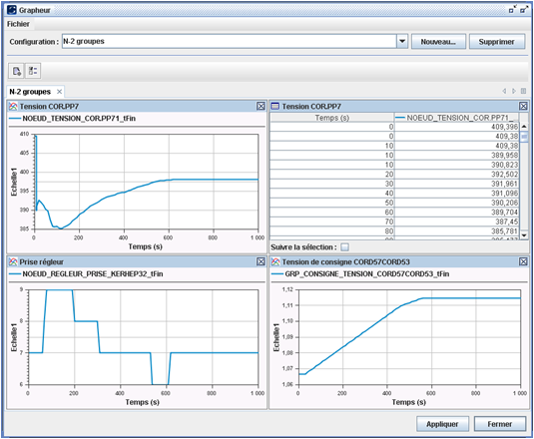
Screenshot from the Study mode: resulting curves for dynamics

Case tree mode
Case tree is a tool to organize all type of studies including studies with structural modifications.
The Case tree mode has been designed for studies which last few days or which require a significant amount of work for building the network use cases. Starting from the base model, only the modifications (state or structure, single or massive scale) are stored. This also allows tracing the study management process.
A function to perform a robustness analysis is available in this context. This function allows assessing the security of the system in case of combination of generation, load and/or topology changes.
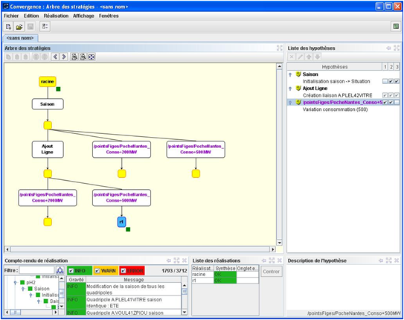
Screenshot from the Case tree mode: use cases developing from a single base model are represented through tree branches; boxes represent modifications on the use cases, purple is used when modification is shared

Data manager mode
Data manager allows managing all the data used by Convergence:
- Exploring own network cases, studies, case trees, modifications (state or structure),
- Collaborative sharing of data:
  - Network cases, studies, case trees, modifications (state or structure),
  - Customized configurations, graphic representations, user interfaces,
- Executing generic processes :
  - Merging or extracting networks (regional and European),
  - Daily generation of 24 DACF, D2CF and IDCF,
  - Flow-based and ATC parameters calculation (PTDF…),
- Importing/exporting in other data formats (CIM, UCTE, EUROSTAG…),
- Managing auxiliary data:
  - Time series definition (generation, load…),
  - External parameters configuration (Xnodes…),
  - Users and groups management (definitions, customizations and rights).

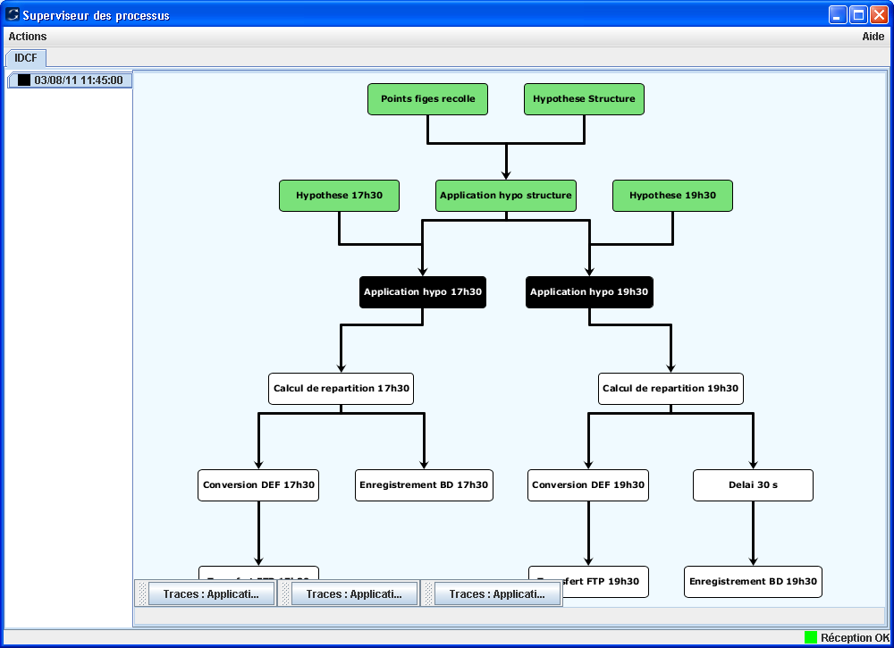
Process supervisor for IDCF generation: base case loading, execution of structure and state modifications (for each timestamp), load flow calculation, UCTE export, FTP transfer, local database copy

Other tools linked to Convergence
None.

Expected CIM functionalities
Convergence allows import and export in CIM ENTSO-E profiles 1st and 2nd edition. The main objective is TSO-to-TSO file exchange for ENTSO-E needs.

CRESO

CESI presentation
Established in 1956, since the beginning CESI has been a market leader in Consulting Activities in the Energy sector, Testing and Certification of electromechanical equipment offering its services to electrical utilities, electro-mechanical and electronic manufacturers, large-scale users of electric power.
Since 2000, CESI has enlarged its fields of activity covering all sectors in the electro-energy fields from generation, to transmission, distribution, end-use of electricity, as well as environment and renewable energies. Now CESI is a global power consultant offering its services world-wide.
In October 2004 CESI took over ISMES, a Company that enables CESI to expand the range of services by working in the fields of environmental risk, design support and structural assessment on buildings and structures, with tests and studies on mechanical and industrial components.
Through the acquisition, in 2005, of IPH (Berlin) and of it's controlled FGH (Mannheim), CESI becomes leader on the international market of electric equipment testing.
CESI has been operating world-wide; has a marketing network in about 40 countries offering its services to:
- Electrical Utilities (production, transmission and distribution)
- Independent System Operators (ISO)
- Regulation Authorities
- Electromechanical and Electronic Manufacturers
- Industrial Users
- Public Administrations
- International Financial Institutions.
CESI activities cover, apart from erection, the whole cycle of a project i.e:
- feasibility,
- design,
- commissioning,
- operation
- disposal.
The offer concerns:
- techno-economic studies on networks, systems, plants and components
- consulting and specialised diagnostic and maintenance interventions
- plant and component life assessment / life extension studies
- management and training procedures and tools
- qualification tests, component, system and plant certification
- supply of testing laboratories, special components
- environmental studies and services: monitoring and assessments, design and realisations, structure engineering, technology developments.

Tool description
CRESO (Network Calculation for Security Operation and Optimization) is a Windows-platform integrated software system that permits the simulation and the analysis of a power network under steady-state conditions, as well as the optimization of the active and reactive power generation. Advanced functions for network studies are also available, such as, for instance, the calculation of the distance from the voltage failure point.
The following are the system main characteristics:
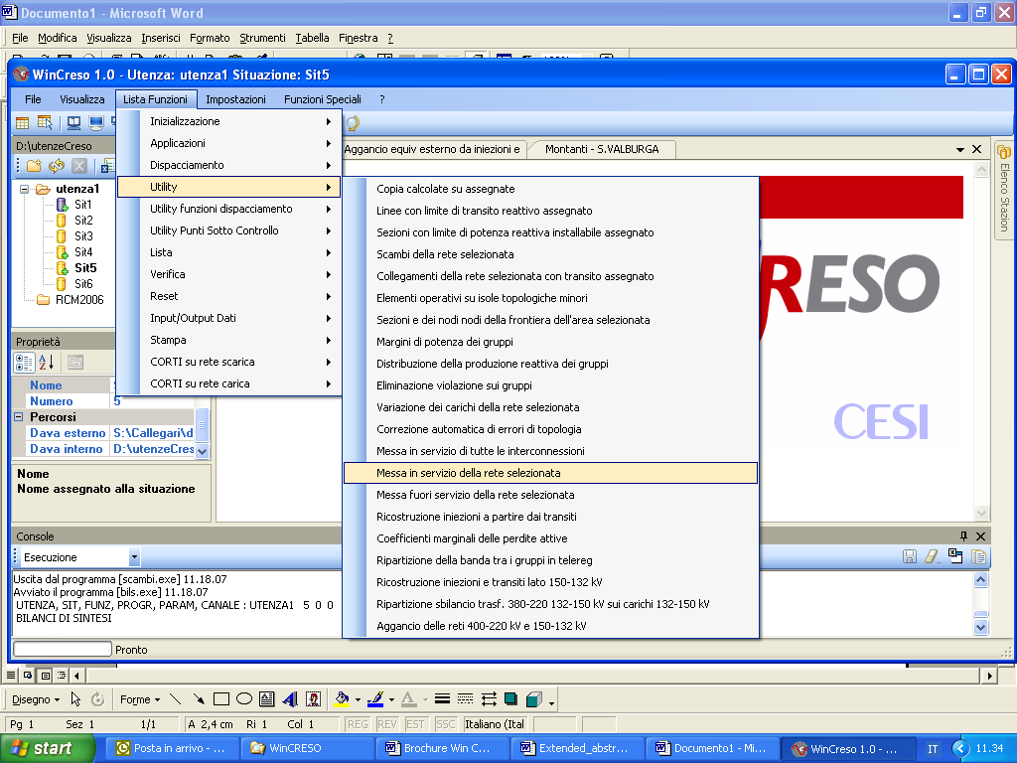
- user-friendly MMI (Man-Machine Interface), promptly understandable and making the operator-system interaction extremely easy;
- extreme modularity of the software architecture, permitting the easy addition of new properties without abandoning a complete integration;
- a complete set of algorithms comprehensive of all the functions necessary for the simulation and the analysis of a power network under steady-state conditions, the security assessment, the optimization of the active and reactive power generation, the short circuit calculation and the harmonic distortion evaluation;
- absolute universality and completeness of the model system and of the algorithmic solutions adopted to implement the different functions; this permits the use of CRESO for the study of any type of network.
Even though it is a typical tool for off-line analysis within operation planning and post-mortem analysis, CRESO can be easily integrated with the Italian on-line control system, this aspect being underlined even more by the fact that CRESO provides also the Estimate of the state, which is a classical function of on-line control systems.
Another remarkable characteristic is the construction of all the data and processing results displays, starting from network data only, such construction being entirely automatic and transparent for the User.
The following are the main functions available with CRESO:
- Acquisition of analogue and topologic quantities; the latter can be provided either as switchgear position or under the more summarized form of electric node
- Estimate of the state and validation of remote signals and acquired remote measurements
- Load flow calculation (considering or not considering the Active/Reactive decoupling)
- Static Security analysis that establishes the steady-state conditions of the network, considering the speed primary regulation of units only, or else the frequency-power regulation. The two versions that consider or do not consider the active/reactive decoupling are available for this function as well
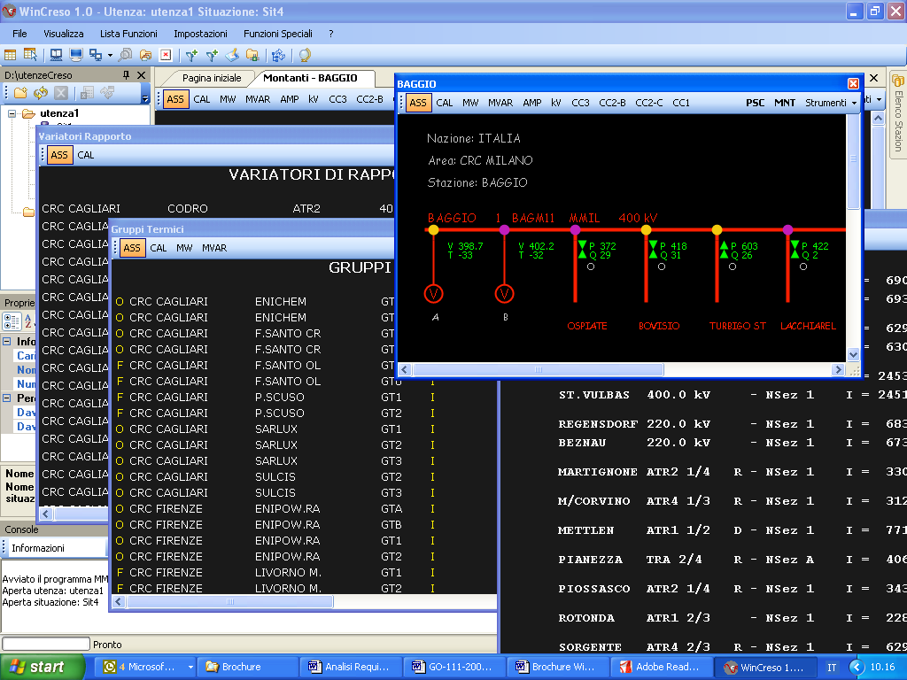
- Security Analysis of the entire network (N-1, with the tripping of transmission lines and power generators), underlining the contingencies that give rise to current and/or voltage violations, also taking into account the system automatic actions, such as primary and secondary power regulation or load-shedding actions
- Optimal dispatching of active power generation (OPF), based on an economic or safety objective function, considering the following constraints:
  - the current passage limits on all the connections;
  - N-1 security limits on a selected set of connections;
  - the limits for the exchange of active power between countries and between different areas within the same country
- Optimal dispatching of the reactive power generation (ORPF), so as to minimize network active losses and to minimize the voltage distortion from and assigned profile, considering also the following:
  - the voltage limits for all the nodes;
  - the reactive power generation limits of the generators
- Security Analysis of Voltage Profiles and calculation of the distance from the failure point, with the indication of the maximum loadability of the system
- Calculation of active and reactive power balances at country level and/or regional level within the same network
- Short circuit calculations, such as calculation of single-phase or multi-phases short circuits, in every bus or along intermediate point of the transmission lines, evaluation of voltage drop, check of the protection system. Furthermore, there are also functions for the evaluation of the harmonic and flicker distortion.
- Numerous functions are available as a support for data validation, for network configuration analysis and for the display and interpretation of results.

The power system model
The network model managed by CRESO is made up of the following components:
- countries;
- stations;
- sections;
- AC lines (for interconnection and loading);
- DC lines (for interconnection only);
- 2-winding transformers (for interconnection and loading);
- 3-winding transformers (for interconnection only);
- tap changers (ratio changers, phase transformers, diagonal and mixed changers);
- thermal units and plants;
- hydroelectric units and plants;
- wind farms;
- synchronous compensators;
- capacitors;
- reactors;
- Thyristor Controlled Series Capacitors (TCSCs);
- Static VAR Compensators (SVCs);
- AC/DC converters.
The main regulations are the following:
- the primary voltage regulation of thermal and hydroelectric units and of synchronous compensators, within their reactive producible condition limit (capability);
- the secondary voltage regulation (area regulation) with thermal and hydroelectric units and possibly with synchronous compensators, interlocked with the same regulator and aligned at the same level of reactive power generation, within their reactive producible condition limits (capability);
- the speed regulation of thermal and hydroelectric units;
- the f/P regulation;
- the regulation of converters;
- the regulation of the secondary voltage of transformers equipped with ratio changer;
- the regulation of the active power flow for the phase shifting transformers and for TCSCs;
- the voltage regulation of SVCs;
- the voltage and frequency dependency of the loads.
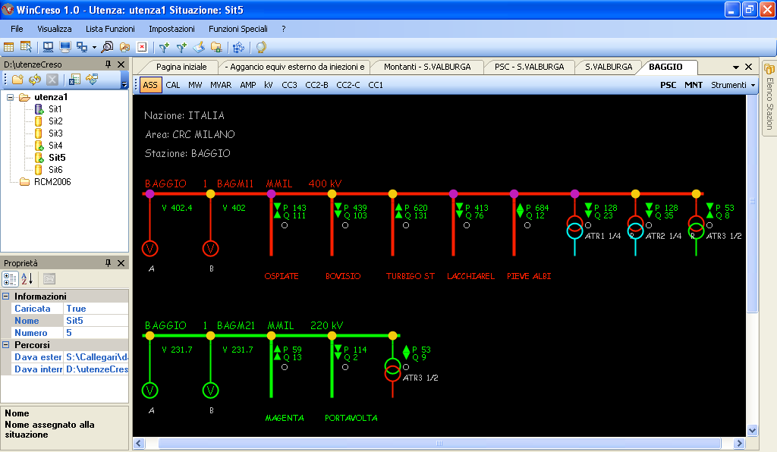
It is worth underlining the possibility of acting on subsets of the network under analysis using the network selection functions made available by CRESO.
The selection takes place at section level on three aggregations of items:
- geographical area;
- managerial responsibility;
- voltage level.
This permits, for instance, the carrying-out of a static security analysis in a selected country to assess whether or not it is in a position to autonomously remedy the active power deficit provoked by the loss of a generator set, avoiding the recourse to adjoining countries.

Navigation within CRESO
The use of CRESO takes place through the navigation across the displays that represent the interface with the user and that can be divided into two large groups:
- layout displays;
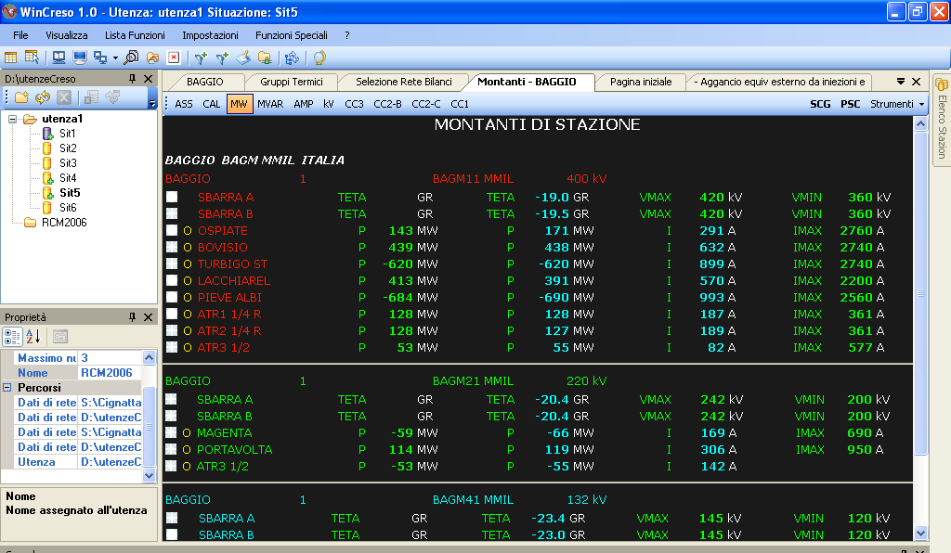
- table displays.
The first type of displays provides the information by means of a graphical display characterized by a high degree of communicability; the displays that illustrate a section layout, for instance, belong to this type: they represent a section layout with its bus bar trunks, its connections to the feeders and the position of the switchgear, as well as the power and current values that flow through the different feeders and the voltage values of each trunk.
The second type of displays, instead, provides the information under the form of tables: such displays are characterized by a high density of information and are fundamental for an appropriate use of instruments.
The passage from one display to another takes place by means of sensitive hyper-links that allow a simple and immediate passage from one display to another.
The information level of individual displays is strengthened also by the use of the overlay technique, that permits the use of the same physical field to display different types of information (such as, for instance, to display first the active power flowing through a given feeder and then the reactive power).

Other tools linked to CRESO
CRESO, with the support of SICRE, is also the tool used to set up the scenarios for the simulations performed by the Dispatcher Training Simulator (DTS) and by the Dynamic Security Assessment (DSA). The links between these tools and CRESO is via internal proprietary format;
- DTS is used for training Control Room Operators as a replica of Control Room System with teaching sessions representing different real situations, from normal condition (e.g. morning load ramp) to extreme critical situation (e.g. blackout).
- DSA is an on-line security preventive assessment; taking the most recent steady state power flow calculation DSA performs the screening of several network contingencies.

Expected CIM functionalities
At the beginning of 2010 CESI starts to support the development of internationally unified data definition and data exchange mechanisms and is therefore committed to integrate and continuously update CRESO in order to cover ENTSO-E needs and rules regarding the reliability of load-flow and short circuits results. Up to now the software is under development in order to be compliant with the models (rev1. and rev 2) used during the IOP tests.
In the future CRESO (used also in the TERNA Operation departments) would include also the operational profile of CIM.
CESI will continue supporting the development of CIM related standards and the innovations supplied with next releases.

DIgSILENT PowerFactory

Vendor presentation

Tool description
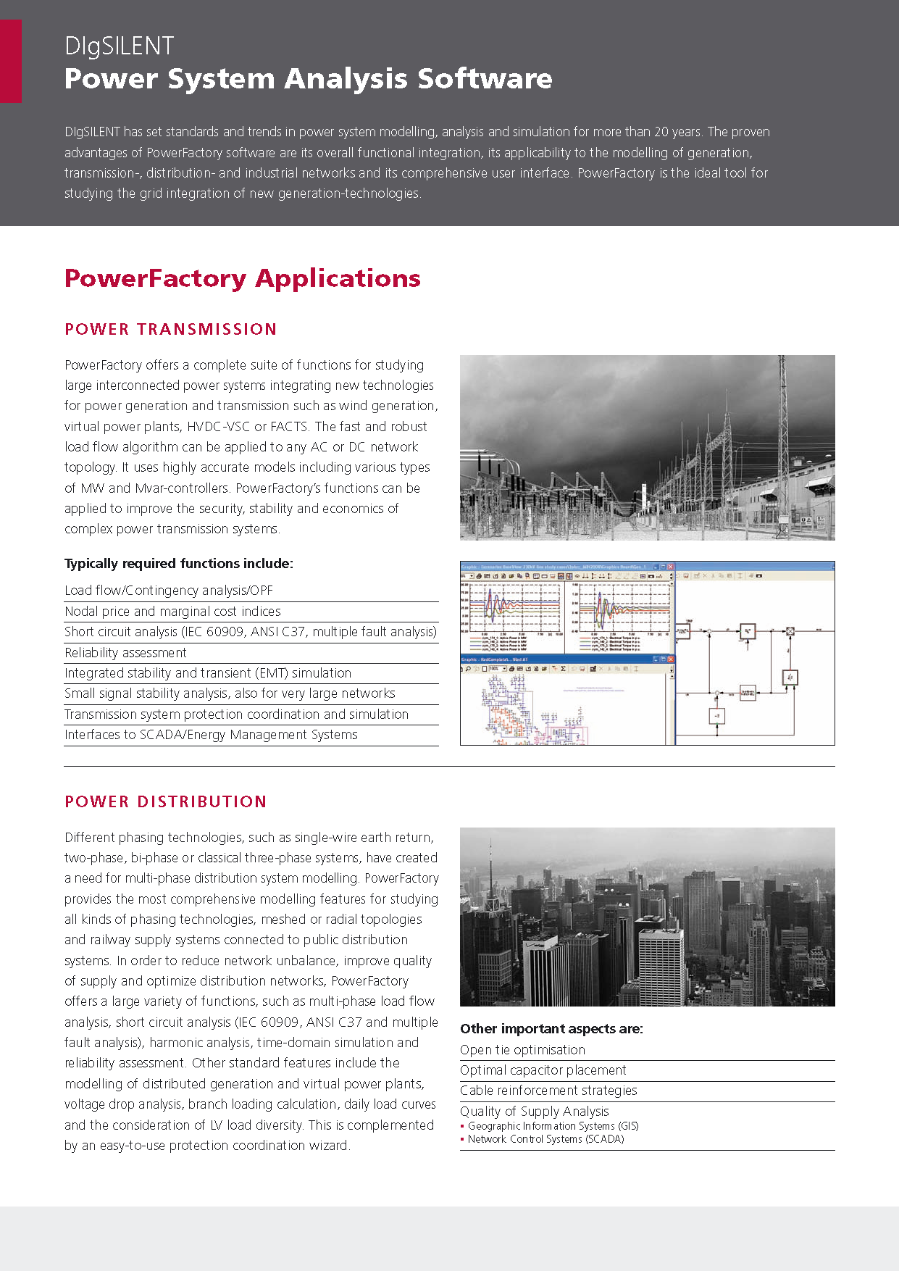
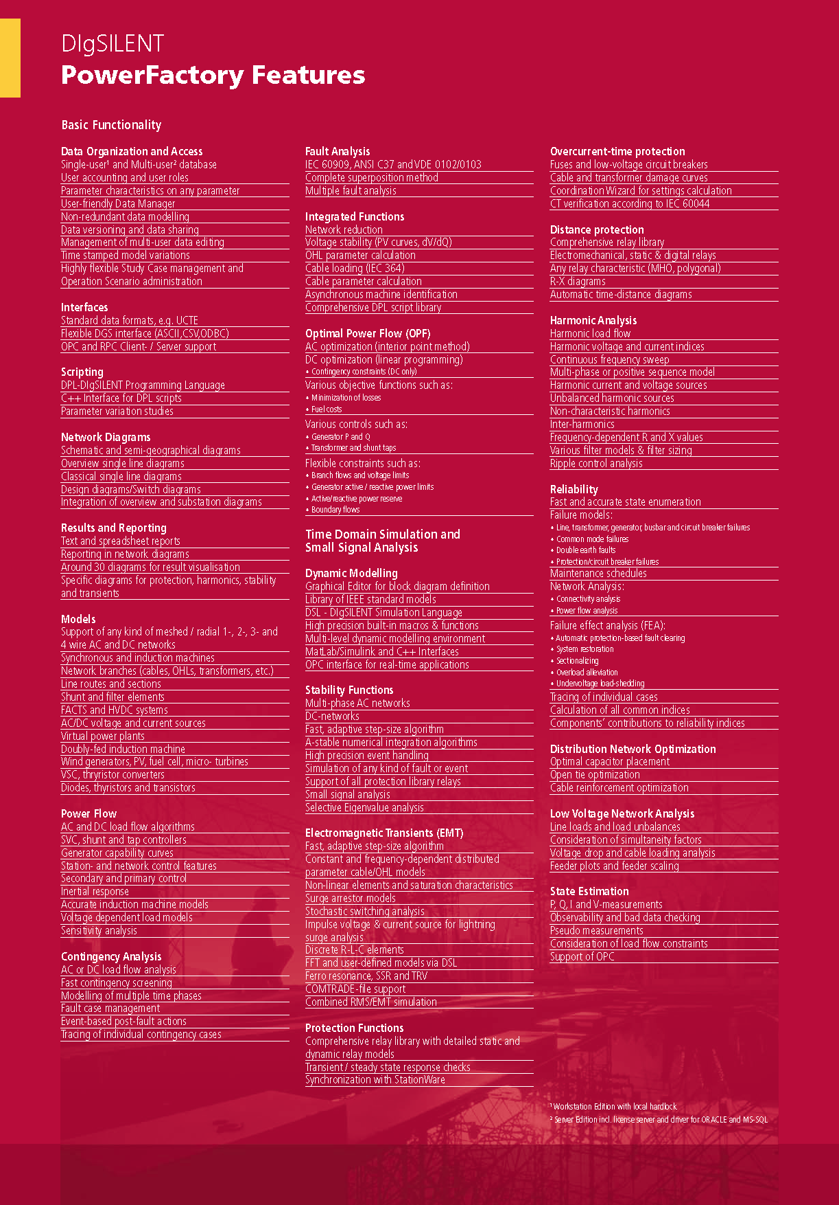

Other tools linked to the PowerFactory Software
PowerFactory does not require any additional software such as an external database for handling CIM data import and export tasks. Typically required tools for handling of various grids, grid scenarios, timed grid expansion stages, data revisions and operational scenarios are integrated to the PowerFactory software data management system incl. 3-way compare and merge tools. In addition, working team is directly supported via multi-user database operation as well.

Expected CIM functionalities
DIgSILENT is supporting the development of internationally unified data definition and data exchange mechanisms and is therefore committed to integrate and continuously update a number of CIM standards.
DIgSILENT GmbH has contributed in the past to the CIM standard development and participated successfully in various CIM related IOPs.
The DIgSILENT PowerFactory software is currently supporting the following CIM profiles:
- ENTSO-E profile 2009
Future versions of PowerFactory will provide data transfer based on:
- ENTSO-E profile 2012
- CIM for Dynamic Models
Further, ENTSO-E planning processes as well as operation processes such as DACF, D-2CF are already fully supported by PowerFactory.
DIgSILENT will continue contributing to the development of CIM related standards and future profiles.

e-terrasource - a Power System Modeler

Vendor presentation
Automation-NMS, the Network Management Solutions division of Alstom Grid, develops and delivers advanced real-time supervision, control, analysis and optimisation tools for Market Operators, Transmission System Operators, Distribution System Operators and independent Generation Companies (Energy Producers). Alstom Grid is a leader in technology research, development and implementation of Smart Grid solutions.
In June 2010, Alstom acquired the transmission activities of the former company Areva T&D to constitute a new sector of the Alstom Group, called Alstom Grid, with 20,000 employees world-wide and about €4 billion annual sales, leader in key markets and fast-growing technologies such as GIS, HVDC and Network Management Systems. Alstom Grid joins the two other sectors of Alstom Group: Transport (trains and metro) and Power (generation plants).
Alstom Grid is structured in 4 sectors: Products, offering a comprehensive range of equipment covering the high to ultra-high voltage up to 1,200 kV (AC) and 1,000 kV (DC) including Power transformers, gas-insulated substations and air-insulated switchgear: circuit breakers, disconnectors and instrument transformers; Systems, delivering turnkey high voltage substations (onshore and offshore), grid interconnection for all types of generation, HVDC interconnections, Power Electronics and special power systems for industry and infrastructure; Services, ensuring maintenance (Inspection, repair, support, spare parts) and optimization of equipment usage through consultancy, expertise, training, refurbishment, extension, upgrade activities; and Automation: N°1 in Network Management Solutions (e-terra), delivers mission critical solutions to protect, control & manage power systems and electrical grids and is a market leader in Substation Automation Solutions.
One of the state-of-the-art products offered by Alstom Grid Automation-NMS is e-terrasource, a generic power systems modeler designed to support utility-wide modelling activities.

Tool description
e-terrasource is a revolutionary step forward in the construction and maintenance of models. It provides a powerful set of features that make modelling tasks easy to coordinate and implement. e-terrasource is a sophisticated, RDBMS-based tool for managing power system models, based on the CIM standards. It provides a full-featured user interface for navigating and editing models, as well as a comprehensive set of web-services for seamless integration with third-party platforms.
e-terrasource supports concurrent operation by multiple users. It captures model changes in annotated and effective dated projects. It supports generation of past, present and future (planned) version of the electrical grid model. e-terrasource manages multiple kinds of models, supports CIM model authority set concepts and provides complete audit trails of activity.
e-terrasource is designed to accommodate changes to the business model schema by supporting versioning of the schema over time. As entities, properties, and relationships are added, removed, and modified, e-terrasource fully supports evolution of the schema by handling migration of model data from version to version.
MAS concept
Whether building a model for a control area, a region, or an entire interconnected grid, e-terrasource supports collaborative model building by allowing a large model to be broken up into smaller pieces that make sense. This design perfectly fits ENTSO-E needs. Each TSO model and each boundary model will kept separately and users can make a query to assemble an interconnect model based on the individual models of their choice as shown in the figure below.
In e-terrasource, the same terminology as in CIM is used. Individual models are referred to as Model Authority Sets. Model Authority Sets need to be non-overlapping. A model is a collection of Model Authority Sets.

Whether building a model for a control area, a region, or an entire interconnected grid, e-terrasource supports collaborative model building by allowing a large model to be broken up into smaller pieces that make sense.

Project concept
The e-terrasource projects contain an ordered list of model changes. Each individual “change item” in this ordered list represents either the addition of a record, the deletion of a record, or the update of a single record property.
A project has an “effective date”, which indicates the point in time that the changes are intended to take effect. This simple feature efficiently provides timestamps of all model changes without the encumbrance of managing timestamps for each individual record.
Projects also have a “current state” property which indicates where the project is in its implementation lifecycle. A sample implementation lifecycle is included, but you can modify it to include steps/states that are relevant for your organization’s modelling business process or workflow.
You may also easily create additional custom attributes for projects (and several other e-terrasource constructs) to track other things that you might be interested in, such as a project category, subcategory, reviewer notes, links to related documents, et cetera.
It is highly recommended that each set of model changes that must take place at the same time be placed in its own project. This way, you can react quickly to last-minute scheduling changes by simply changing the project’s effective date, thereby avoiding the tedium of backing out model changes that have been rescheduled. In other words, it is generally to your benefit to have several small projects as opposed to a single monolithic project.
Model changes made by a user are saved to the user’s “active project”. e-terrasource makes it easy for users to create new projects and choose which project is “active”.
As implemented projects accumulate over time, they can be “rolled up”, or combined, with a model authority set to form an updated model authority set. This updated model authority set generally forms a new baseline for making future model changes.
e-terrasource provides network modelling storage capabilities. e-terrasource manages the construction and maintenance of system models. Business systems that help plan or operate large complex structures like an electric power transmission system require computer models that define the system that they are to manage. Like their physical counterparts, such computer models are themselves large and complex – they also must be accurate in order for the business systems to function properly. e-terrasource is a tool for efficient development and maintenance of models.
The e-terrasource metamodel can be modified to support new classes and attributes. CIM ENTSO-E profile 2nd edition (draft, July 2011) already includes breaker objects, which can be optionally modelled by TSOs submitting models. Therefore, e-terrasource will be able to import, assemble and export network models with or without breakers.
Workspace management
The e-terrasource introduces the concepts of Workspaces which play a large role in the management of changes, and enables modelling teams to work more collaboratively. All user activity takes place in user “workspaces”. Workspaces allow, for example, one user to be working on immediate changes to the current model, while another is working on a future condition. Through the standard e-terrasource user interface, each individual user can view, validate, make changes to the model and export it, independent of work that other modellers are performing, each in their own workspace.
For more information, send email to jay.britton@alstom.com .

Other tools linked to the e-terrasource
e-terrasource is linked to e-terraplatform (Alstom’s EMS product) and to e-terradistribution (Alstom’s DMS product).

Expected CIM functionalities
e-terrasource is especially targeted toward the cooperative development of models that must take place in large interconnected power grids such as that covered by ENTSO-E. It provides members or regional entities in such an interconnection a tool for managing their own model territory and for constructing analytical models from submitted models of other members.
e-terrasource metadata model can be customised to exactly match a given CIM profile version. It can efficiently support import, validation, storage and export of many different versions of network models from several TSOs. Business rules can be incorporated as validation procedures to verify the quality of submitted models. Thanks to the Model Authority Set concepts, models from different TSOs can be merged in e-terrasource and exported to external users.

EUROSTAG®

Vendor presentation
Eurostag is co-developed by RTE and Tractebel Engineering.

Tractebel Engineering
Tractebel Engineering is part of GDF SUEZ Energy Services, one of the business lines of GDF SUEZ and the European leader in multitechnical services.
With about 3,700 employees around the world, Tractebel Engineering (GDF SUEZ) is one of Europe’s major engineering companies, and offers state-of-the-art engineering and consulting solutions to power, nuclear, gas, industry and infrastructure customers in the public and private sector. Services include a full range of engineering assignments throughout the lifecycle of the customers’ installations: architect engineer, owner's engineer and consulting engineer.
Power System Consulting (PSC), belonging to Tractebel Engineering (GDF SUEZ) is a group of 40 high profile electrical engineers and mathematicians acting worldwide as consultant in power system operation and development. PSC is a centre of excellence in power system analysis for the delivery of high added value services to public and industrial power systems.

RTE
RTE is the French TSO. (www.rte-france.com).
The missions of RTE are:
- Balancing electricity generation with consumption at all times
- Guaranteeing the secure operation of the power system (carrying electricity 24 hours a day, 7 days a week)
- Maintaining and developing the network to allow generators, distribution networks and consumers to be connected, as well as interconnection with neighbouring countries
- Guaranteeing non-discriminatory access to the transmission network, whilst ensuring that commercially sensitive information remains confidential
- Integrating transmission installations into the environment and ensuring the security of people and property
all at the most economical cost possible

Tool description
Objective
Accurate simulation of the dynamics in all electric power systems.
Application
EUROSTAG® covers the full range of transient, mid and long-term stability, from electromechanical oscillations up to daily load evolution. By allowing understanding in depth all critical system mechanisms, EUROSTAG® helps solving
- conventional problems such as critical clearing times, power oscillations, tuning of generating units controllers, or load shedding policies
- as well as highly complex power system problems such as voltage collapse and black-out scenarios, set up of defence plans and restoration procedures, transfer capability, study of centralized voltage or frequency controls, or power electronics : FACTS and HVDC.
It also provides an entry point for new opportunities such as on-line dynamic calculations in EMS, system modelling in an integrated environment for analysis, and use of other compatible simulation applications. In every way, EUROSTAG®
A unique algorithm
EUROSTAG is based on a unique and robust algorithm using a continuous varying integration time step-size from 1ms to 100sec which will adapt automatically to the accuracy requirement. The step-size becomes short if a fast phenomenon (such as a loss of synchronism) is excited. It remains long and allows extended simulations (up to several hours) if only slow phenomena are excited.
Main advantages
- Continuous display of both fast and slow phenomena – EUROSTAG ® enables scenario simulations of a few seconds to several hours, making it ideal for studying conditions over time in which fast and slow phenomena interlock.
- Reliable simulation – EUROSTAG ® replicates and integrates all power system components, as well as the actions of operators, to produce authentic real-time dynamic simulation. Observation of any physical variation is possible at any moment, without any prior declaration.
- Flexible but secure power system modelling – EUROSTAG ® offers a vast library of power system models (including dispersed and renewable generation facilities) and processes. These can be used directly or modified - using an advanced modelling language that automatically generates the appropriate equations, removing all risk of human error. It allows representing in a specific way any type of process or controller, whatever the technology.
- Open software - EUROSTAG® reads data in international formats and can recover models and parameters used in older programs. Results can also be exported to other specialised programmes (Mathworks Matlab®, Microsoft® Office). EUROSTAG 4.5 is also CIM compliant.

- Faster and easier studies – EUROSTAG® offers a user-friendly graphical interface for rapid modelling, data edition, simulation, results interpretation and analysis. The advanced modelling language enables for instance the customization of standard existing models or the input of new models, directly on the screen without any programming.

Other tools linked to EUROSTAG

Tractebel Engineering
Tractebel Engineering developed the following tools linked to EUROSTAG®:
- Three complementary modules that can be plugged on EUROSTAG®
    - Dynamic security assessment (SYSCAN);
    - Dynamic Response Optimization (STAG-O!);
    - Small signal stability (HERCULES).
- PSA PLATFORM, for both Advanced Dynamic and Static Power System Analysis, that includes EUROSTAG®
Static
    - Load-Flow;
    - Contingency Analysis;
    - Short-circuit calculation (static).
    - Short circuit currents (SHOCC);
    - Optimum power flow (IPSO);
    - Network reduction (REI).
Dynamic
EUROSTAG® (cf. above)
    - Dynamic security assessment (SYSCAN);
    - Dynamic Response Optimization (STAG-O!);
    - Small signal stability (HERCULES).

- FAST, dynamic real time Dispatcher Training Simulator. FAST is compatible with EUROSTAG®.

The PSA Platform is a planning tool where the different integrated software solutions are using the same internal format. Supporting CIM with EUROSTAG® will facilitate to connect the whole PSA Platform to CIM.
On the other hand, our real time Dispatcher Training Simulator FAST uses an operational model and is thus concerned with the CIM CPSM.

RTE: ASSESS
ASSESS allows to generate new systematic or random situations modelling the uncertainties. It is possible to model uncertainties on any variable defining the studied network.
To do so, the user has access to a great variety of probability laws. In a typical ASSESS study, the user generates between 1000 and 30000 new situations. Then each situation can be analyzed with a full range of tools.

Expected CIM functionalities
The aim is to be able to import CIM data files in EUROSTAG®, run simulations on those cases and export the results in CIM format. EUROSTAG® being not a daily exchange tool, we are more interested by the full model exchange than by the split by MAS, incremental or partial exchanges.
The first step was to be compliant with CIM static data files. The version 4.5 of EUROSTAG® is already compliant with the CIM ENTSO-E Edition 1.0.
The next step is to take into account CIM dynamic data in the next versions of the software.

Integral 7 (FGH)

Vendor presentation
FGH GmbH is a subsidiary of the nonprofit research organization FGH e. V. (Forschungsgemeinschaft für Elektrische Anlagen und Stromwirtschaft e. V.) with offices in Mannheim and Aachen, Germany. Based on a 90-year tradition FGH enjoys high reputation in the field of electrical power and energy industry. The high technical and methodological expertise of FGH is based on a broad field of activities, going from Research & Development (R & D) across advisory services, training events, and software development to active participation in and management of standardization processes at national and international level.
For more than 30 years software development has been a core competence of FGH. Together with our member companies, FGH has conceived and is continuously improving the network planning system INTEGRAL.
With the program INTERASS, FGH offers another leading software product for the collection and evaluation of disturbance data according to the statistic schemes of FNN and VEÖ.
Beside the standard products INTEGRAL and INTERASS, FGH develops individual software solutions that support special processes in utilities.
Internet: http://www.fgh-ma.de

Tool description
INTEGRAL is a powerful tool for the planning of electrical power systems. The roots of INTEGRAL go back for more than 30 years. Until 1974 the German TSOs did their own development of software for network analyses. In 1974 finally their efforts were centralized at FGH and a first program for power flow and short-circuit calculation was developed. In 1982 the first graphical output of networks was added and since 1986 the user is able to interact via a graphical user interface. Since 1990 additional calculation modules like state estimation and voltage-var optimization were added.
Main calculation modules in INTEGRAL are:
- Power flow calculation and outage simulation
- Short circuit calculation according to IEC 60909 (single fault and Takahashi’s method)
  - 1-phase faults
  - 2-phase faults (with/without ground connection)
  - 3-phase faults
- Universal fault calculation: Definition of arbitrary fault combinations (with/without consideration of the current power flow situation)
- Extended Ward network reduction (separately for power flow and short circuit calculation)
- State estimation
- Calculation of line parameters for overhead lines
- Reliability analysis
- Voltage-var optimization
- Simulation of fault clearing
- Analysis of harmonics propagation
- Cost analysis
Customer specific program modules can be developed and integrated into the graphical user interface.
INTEGRAL uses a detailed data model with complete modelling of the switch gear. This is a prerequisite for reliability analyses, simulation of fault clearing and cost analyses. But it also enables automatic creation of network graphics from the data model. Figure 1 shows the graphical user interface of INTEGRAL with an open network graphic.
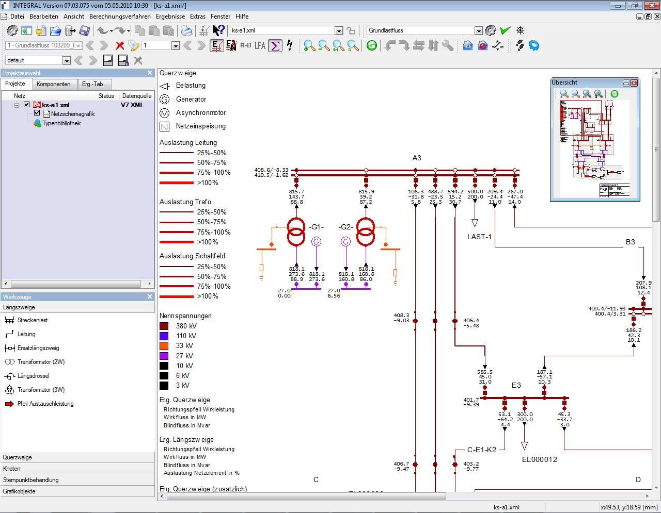
Fig. 1: GUI of INTEGRAL 7 with open network graphic
Additionally to the classic network graphic INTEGRAL provides a geographical presentation of the network, shown in figure 2. This geographic presentation gives a simplified overview of the network. Some calculation results can be visualized by background colors. This graphic is also an easy way to define a route model of the network.
Routes connect substations. They can bare poles and trenches. If overhead lines are assigned to poles, the line parameters of the overhead line can be calculated from the pole geometry (fig. 3), including mutual couplings. Also poles can be used to easily define common-mode failures for reliability analyses.
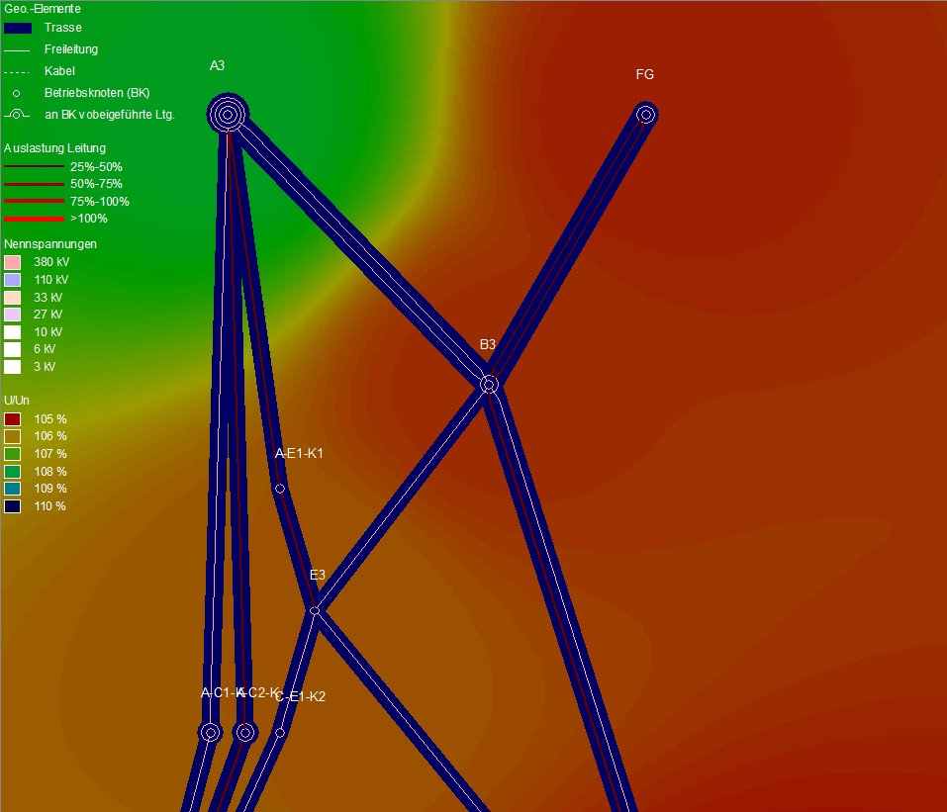
Fig. 2: Geographical presentation with visualisation of voltages as background color
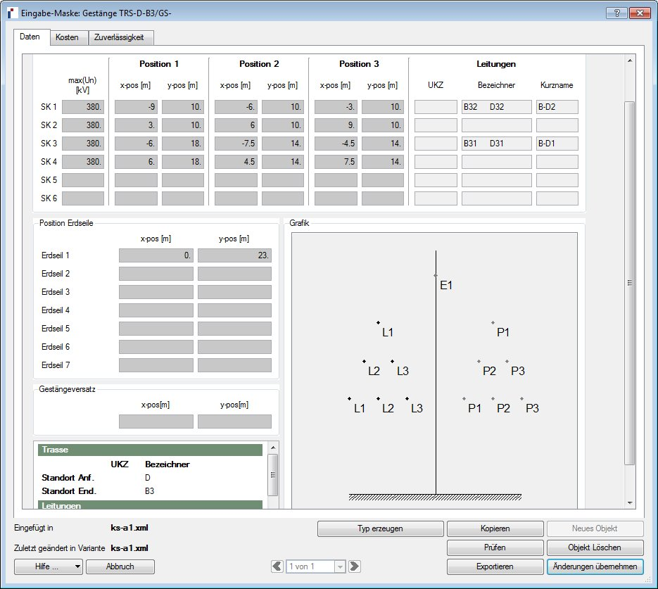
Fig. 3: Template for pole geometry
Periodical execution of always the same working steps is time consuming. Therefore in INTEGRAL a macro language is integrated to automate working procedures. The macro language is based on JavaScript. More than 3000 instructions allow access to the complete data model and calculation modules of INTEGRAL. Additionally it is possible to create own GUIs within the macros.

Other tools linked to Integral 7
None

Expected CIM functionalities
In the future the connection to a stability program is planned. After that also the CIM import/export routine can be extended to dynamics data.

ISPEN

Vendor presentation
Intercompro has more than 30 years of experience in the field of Power Application Software. The focus is on simulation software used by the dispatchers in the control centre of a TSO.
http://www.ispen.ch/

Tool description
ISPEN is the centrepiece of a product family specialized for on-line applications. The software can simulate networks of the magnitude 25'000 nodes and 30'000 lines. The basic import interfaces are designed for:
- UCTE-DEF
- CIM/XML
The import features allow the user to enter n MAS files of the kinds EQ, TP and SV in order to form the desired network. Thus, n EQ files serve as input to the EQ import converter and the corresponding n TP and SV files serve as input to the TP and SV import converters.
The export can be done in UCTE-DEF format or in the CIM/XML format with EQ, TP and SV files. The exported EQ file is the same file(s) as once was imported since the simulations carried out in ISPEN do not involve any creation of new network elements.
The CIM/XML import converters is a very fast high performance software that converters the large network (9'600 nodes) used at the UCTE 2009 interoperability test held in Paris in about 4.5 seconds when running on a standard lap-top.

Other tools linked to the ISPEN
All the tools in the ISPEN family have a common proprietary data structure and each tool can use ISPEN to perform import/export as described in the previous section.
An outstanding tool is ISPEN/OCD that is used by several TSOs for the automated monitoring of the N-1 security. This is a standard application in which the on-line network of the TSO is embedded in the ENTSO-E network model of the European interconnected network in order to have a real external network that is needed to model the erratic flows of the deregulated energy market. The execution of a standard N-1 contingency list for a large power system with about 9500 nodes and ca 1400 contingency cases is done in about 13 seconds. This very fast performing software allows any TSO to detect any N-1 problem in time to carry out counter measures.
http://www.ispen.ch/

Expected CIM functionalities
One major development of the tool will be to import state estimation results from a SCADA/EMS system that will be used as base case for the ISPEN on-line applications.
A second development involves the import of short-circuit data in order to carry out a standard 3-phase symmetrical short-circuit calculation as security check in the dispatching of a TSO.

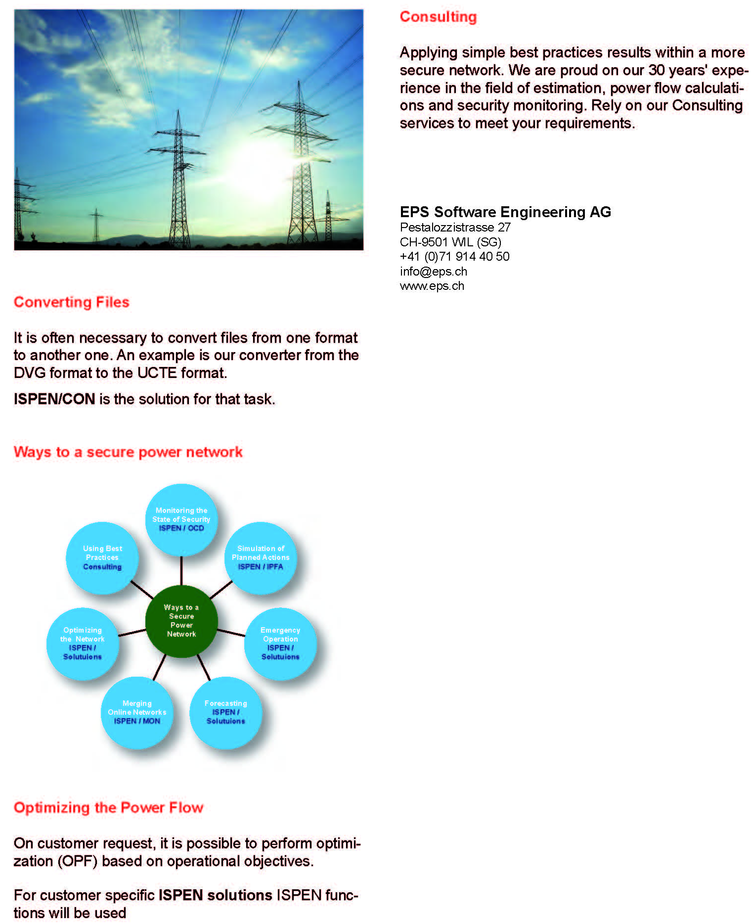
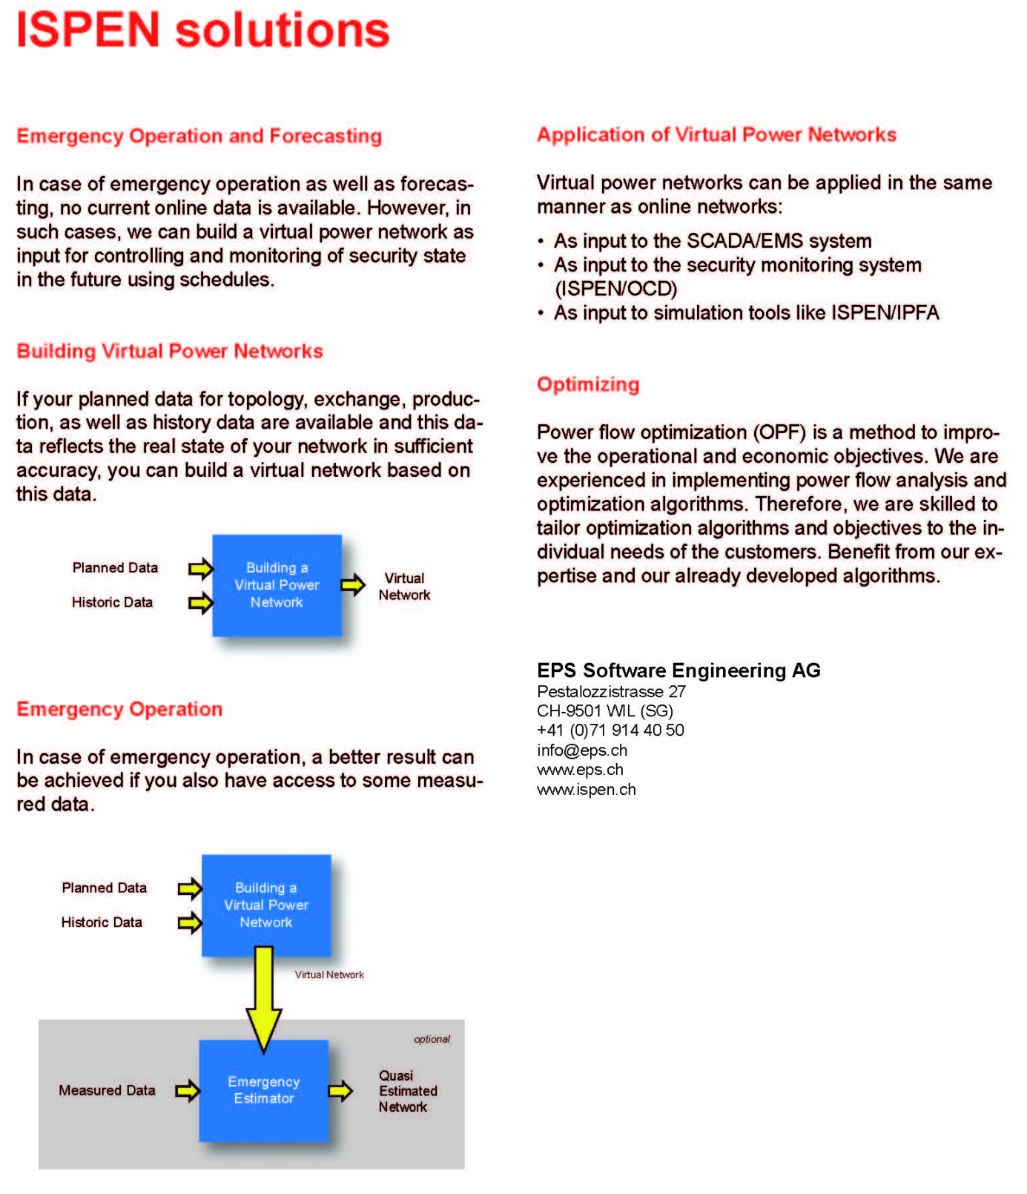

NEPLAN®

Vendor presentation
BCP Busarello + Cott + Partner AG was founded 1988 in Zurich, Switzerland and is specialized in the field of power systems engineering. BCP is the developer and owner of the power system analysis tool NEPLAN and is one of the leading companies in the power system engineering software market. Small and large utilities, industrial organizations, engineering companies and universities in more than 90 countries around the world appreciate our high Swiss quality products.
BCP is member of the international NEPLAN®-Consulting group, which offers a wide range of power system studies and consultancy work, like network reliability analysis, defining new maintenance concepts, stability studies, consultancy on integration of wind energy and much more. Within this NEPLAN ®-Consulting group we have successfully carried out more than 1000 power system analysis and planning studies with NEPLAN®.
Product: NEPLAN
Company: BCP Busarello + Cott + Partner AG
Bahnhofstr. 40
CH-8703 Erlenbach (Switzerland)

Web: www.neplan.ch
E-Mail: giatgen.cott@neplan.ch

Tool description
NEPLAN® is a high end power system analysis tool for transmission, distribution and industrial networks. It is the most complete tool on the market.
NEPLAN® 360 is the revolutionary world’s first browser and web based analysis tool. It offers all advantages of cloud computing

A quick overview about the NEPLAN functionalities may be found here:
http://www.neplan.ch/pdf/english/factsheets/NEPLAN.pdf

Further information about the NEPLAN Transmission package may be found at:
http://www.neplan.ch/pdf/english/packages/NEPLAN_TransmissionModules.pdf

Further information about the NEPLAN Distribution package may be found at:
http://www.neplan.ch/html/e/pdf_e/NEPLAN_DistributionModules.pdf

Further information about the web based NEPLAN 360 version may be found at:
http://www.neplan.ch/html/e/e_PowerSystems_Properties_default_web.htm
…and examples here..
http://www.neplan.ch/html/e/e_PowerSystems_Examples_default_Web.htm#

NEPLAN® - Maintenance is an asset management tool, which allows to medium and long-term budget planning. Asset managers can optimize the investment timing, the network structures, the network operation as well as the power supply reliability and its quality.

The NEPLAN^{® -}Asset Simulation Module is a perfect tool for the asset manager of power systems.
It simulates the future behavior of network components based on experience of the past. Among others, the module calculates the CAPEX and OPEX costs for each year of simulation.

More information may be found here:
http://www.neplan.ch/html/e/e_asset_management_new.html

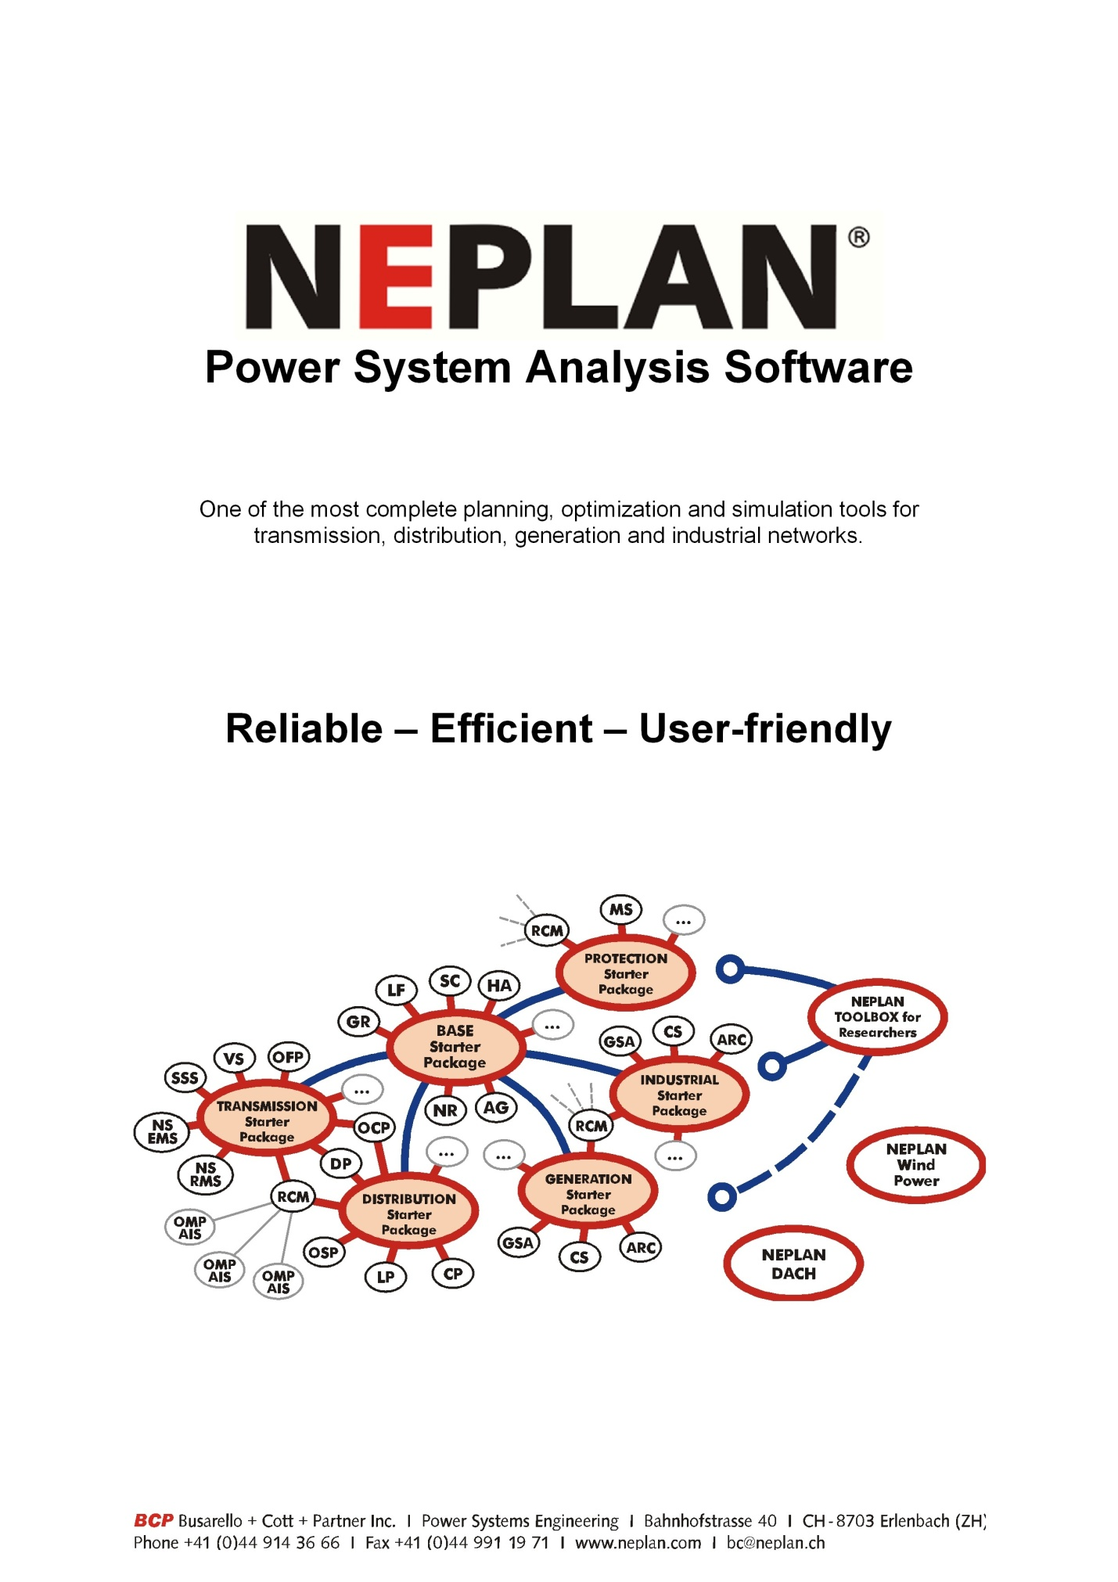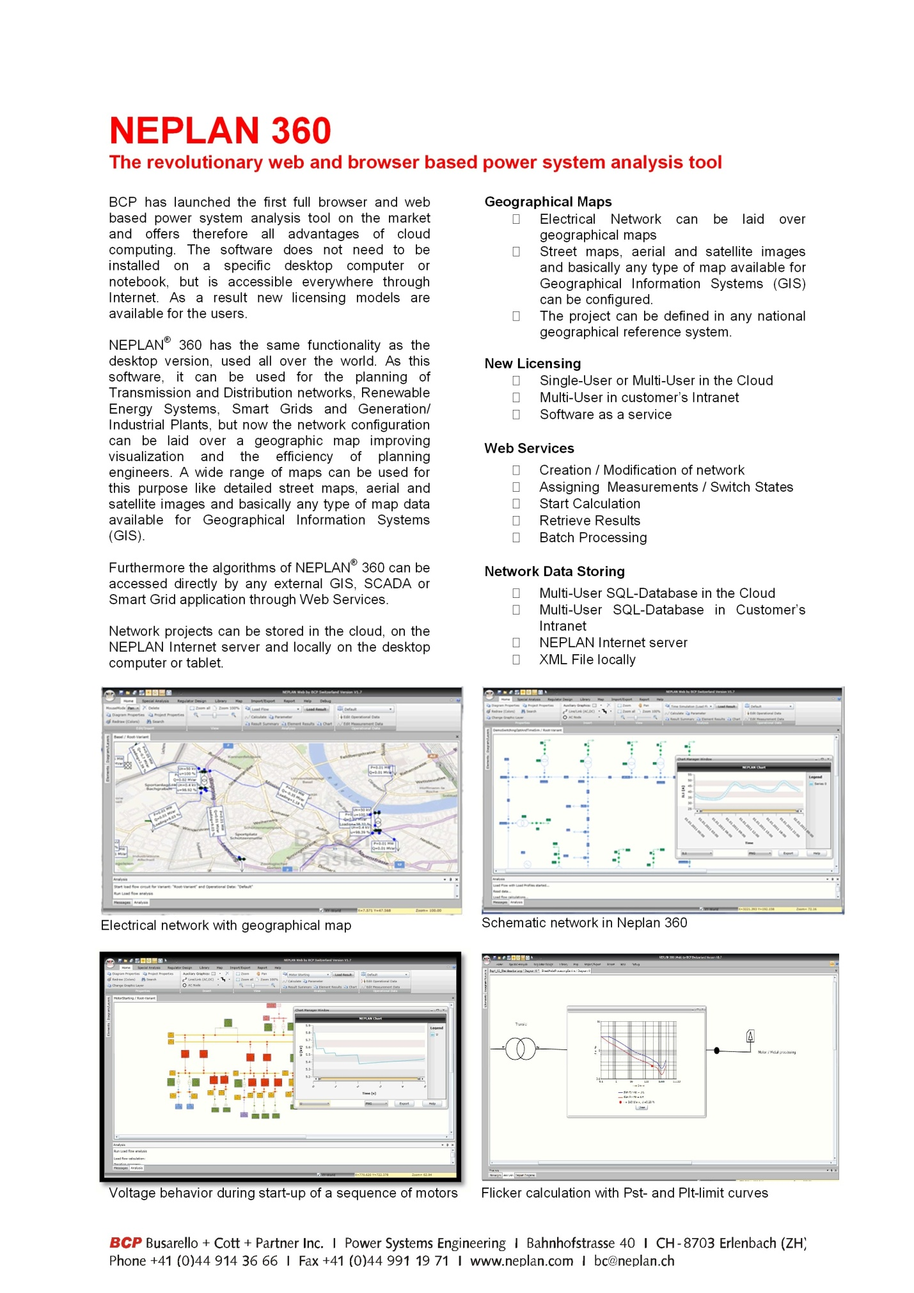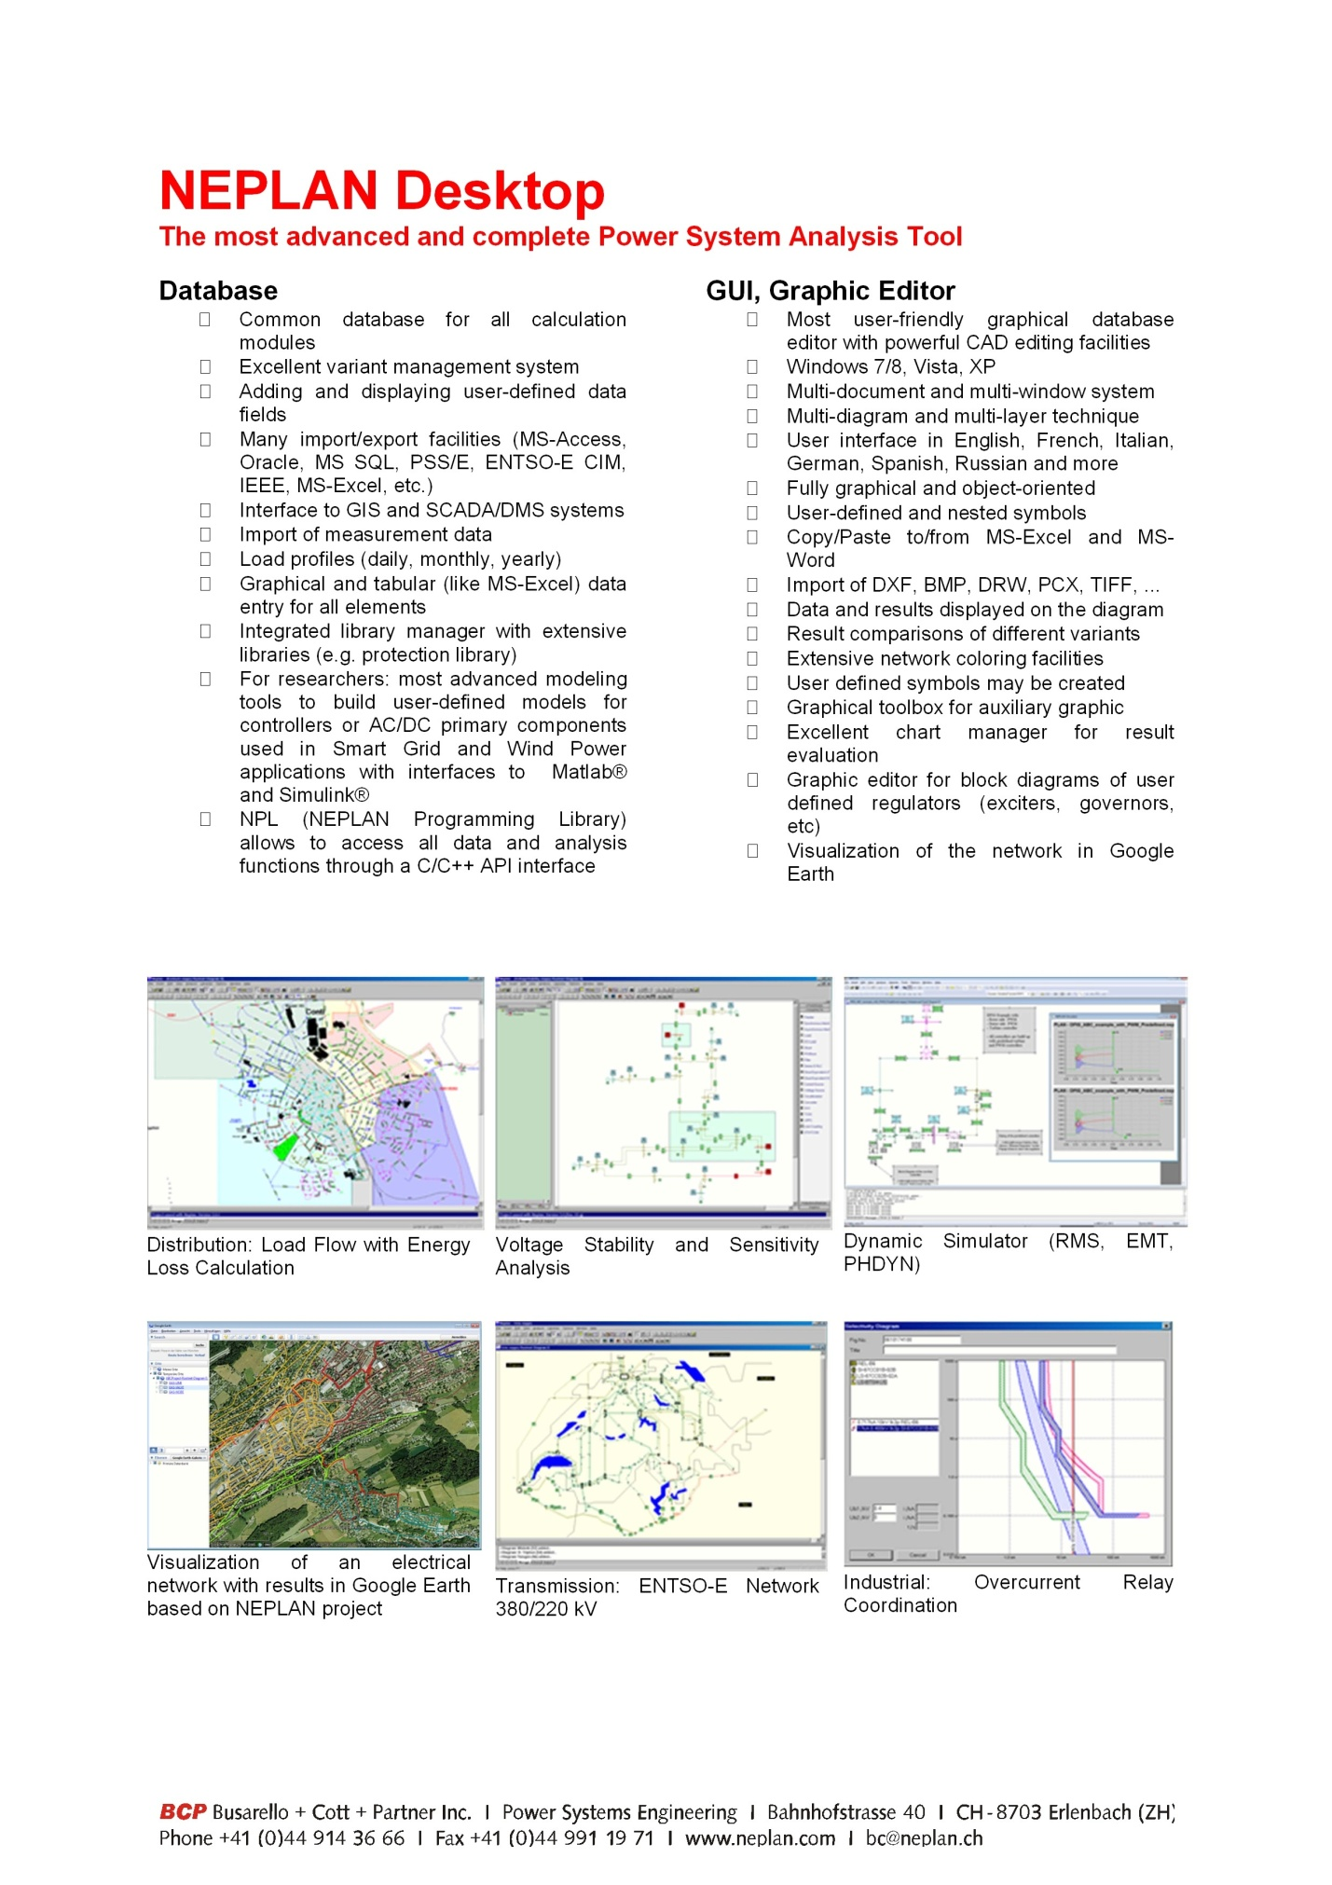
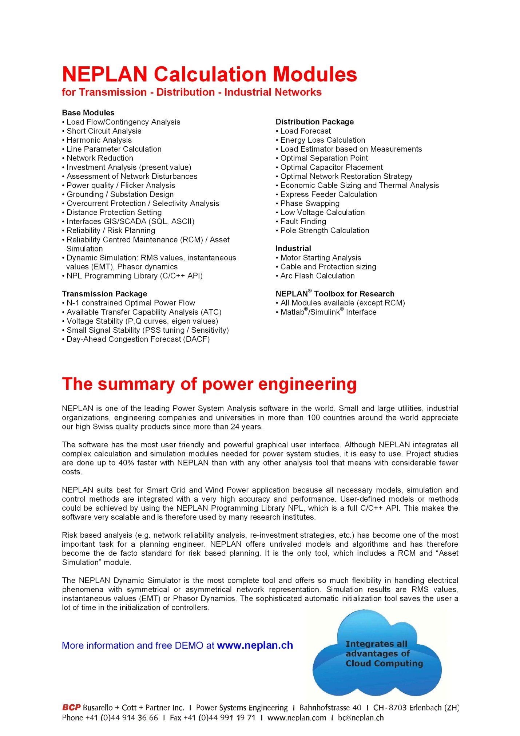

According to our customers NEPLAN distinguishes oneself especially by these features:

- It is very easy to use. The graphical user interface is very user-friendly and offers all features of a modern CAD system. Planning task may be done extremely efficiently.

- It is a very complete analysis tool, with a huge range of different analysis modules. It offers for every electrical phenomenon in a power system network a calculation module. Main modules for transmission networks are:

single line diagram editor, power flow, short circuit analysis, transient stability, EMT analysis, voltage stability, contingency analysis, protection coordination, OPF, NTC, C/C++ API to develop user defined applications and more.

- The “NEPLAN® Risk based planning” tool is the benchmark tool for investigation of the power system network reliability (e.g. SAIFI, SAIDI).
Further info at
http://www.neplan.ch/html/e/e_brochures_default.htm

- NEPLAN® is a very open system. The NEPLAN® algorithm and functionalities may be easily integrated into any existing environment like a GIS (geographical information systems) or SCADA/ DMS systems through a C/C++ API. NEPLAN® may be connected directly on a TCP/IP bus and used as calculation server or as a GUI client. This architecture allows building user defined flexible applications like DACF implementations or sophisticated SmartGrid concepts.
Further info DACF:
http://www.neplan.ch/pdf/english/modules/NEPLAN_T05_DACF_engl.pdf
Further info C/C++ API:
http://www.neplan.ch/pdf/english/modules/NEPLAN_B11_NPL_engl.pdf
Further info SmartGrid:
http://www.neplan.ch/pdf/english/factsheets/e_neplan-SmartGrid-v2.pdf

- The NEPLAN® dynamic simulator” offers unrivaled features for transient stability and electro magnetic transient analysis. It is fast and easy to use. It includes many predefined models. Researchers and developers like the powerful modeling capabilities for developing new models and control strategies (e.g. for renewable energy systems like wind power and solar energy plant).
Further info at:
http://www.neplan.ch/pdf/english/modules/NEPLAN_B08_Simulator_engl.pdf

- The NEPLAN® allows modeling of all types of renewable energy resources (DER) in an extremely easy and efficient way. Many models are available in NEPLAN.
Further info at:
For wind power systems modeling:
http://www.neplan.ch/pdf/english/factsheets/e_dynamic_wind_power_simulation.pdf
For other renewable energy resources modeling:
http://www.neplan.ch/pdf/english/factsheets/Distributed-Generation.pdf

Other tools linked to NEPLAN®
- BCP develops also analysis tools for Gas, Water and District Heating Networks. All data may be accessed via MS-Excel or SQL database.
- The ‘NEPLAN®-Asset Management’ product includes two main modules:
  - Reliability Centered Maintenance module
The radical changes taking place in the energy markets are putting huge pressure on the affected companies to cut costs. There is considerable potential for this in the field of maintenance, among others. By selecting suitable custom maintenance strategies, the cost of maintenance can be substantially reduced without putting the required functionality at risk. The ‘Reliability Centered Maintenance’ module includes a budgeting tool, which calculates the cost for the following maintenance strategies:
    - Corrective
    - Time-based
    - Condition-based
    - Reliability-centered

  - Asset Simulation module:
It simulates the future behaviour of network components based on experience of the past. Among others, the module calculates the CAPEX and OPEX costs for each year of simulation. The asset simulation helps the asset manager, together with the future objective network and maintenance strategy, to optimize:
    - Investment timing
    - Network structures
    - Network operation
    - Power supply reliability and quality

The asset management product integrates smoothly into our NEPLAN power system analysis tool. The results from the NEPLAN risked based analysis may be used as input. The data are stored in a SQL database (like Oracle, SQL-Server, MS-Access, etc.) and is as such unique on the market.
More information about our asset management product maybe found at: http://www.neplan.ch/html/e/e_brochures_default.htm

Expected CIM functionalities
1) BCP will integrate future CIM standards. BCP will continue to contribute to CIM standards for various applications (e.g. load flow, short circuit, dynamics, single line diagram, geographic diagram etc.)
2) We will further improve the NEPLAN risk based simulation and the asset management modules, since we see that here is a big cost savings potential for many utilities.
BCP may help in CIM standards for asset management and asset simulation.
3) The NEPLAN Programming Library (C/C++ API), which allows building customized NEPLAN procedures and products (e.g. SmartGrids), will be enhanced with additional functions.
BCP may help in CIM standards for data exchange via API.
4) The ‘Phasor Dynamic Algorithm’ of the ‘NEPLAN® Dynamic Simulator’ module will be improved. The ‘Phasor Dynamic Algorithm’ allows more accurate simulations than the traditional transient stability algorithms (RMS simulations) and is more computationally efficient than the traditional EMT simulations for phenomena’s which are outside the fundamental frequency range. Additional models for renewable energy systems will be added.
BCP may help to define CIM models for renewable energy and smart grid systems.
5) With NEPLAN 360 BCP has released the first web and browser based tool, which offers all advantages of cloud computing. In future data exchange will be done through web services.
BCP may help to define CIM standards for exchanging data via web services.

Network Manager SCADA/EMS

Ventyx/ABB presentation
Ventyx, an ABB company, is the world leader in network management, providing SCADA-based network management and central market systems in our Networks & Markets solution suite. Our full-range solutions enable utilities to collect, store and analyze data from hundreds of thousands of data points in national and regional networks and are playing a very central role in the on-going development of smart grids. As part of the ABB Group, Ventyx solutions are helping to meet growing demand for electricity by raising the efficiency of electricity systems and helping to incorporate renewable energy into the grid.

Tool description
NETWORK MANAGER EMS
Secure and reliable grid operation
Network Manager EMS is the right Control Center solution to manage your complex energy system processes and reduce your operating costs, while maintaining the required levels of cyber security. Network Manager EMS is also an Energy Information System that provides reliable process information to all levels of decision makers in your organization.
Network Manager EMS is an open and versatile system that conforms to all the relevant industry standards. It can be configured to meet the specific needs of each Utility, allowing for simple integration with Corporate Information Systems. It also provides a comprehensive set of tools for smooth system maintenance and expansion.
Network Manager EMS facilitates an efficient, secure and reliable grid operation, not only for managing today’s power networks but also for tomorrow’s Smart Grids, with rapidly expanding sources of renewable energy.
Situational Awareness
The philosophy behind the Network Manager EMS functionality is to provide both the tools and the incentives to increase efficiency and optimize power system operation. Lack of information is not always the problem for operators of the electrical grid;, it is rather the timely interpretation and presentation of the information available.
Network Manager EMS comprises not only advanced calculations and algorithms but also a visualization concept to make the Operators aware of the current operating state of the system. Both Operators and users at other levels will benefit from increased situational awareness thanks to the dynamic information and the presentation techniques within Network Manager.
Flexible and robust architecture
Network Manager EMS comprises a set of components that can be combined and implemented in a flexible way to meet the requirements of each individual Utility. This includes both the hardware and the software so that for example a Control Center can be expanded with another set of servers, a back-up Emergency Control Center or a remote Operator work station as the needs or requirements change.
Advanced Network Applications
Managing the transmission grid involves planning, monitoring and controlling the available assets to achieve and maintain an optimal operating state. Network Manager EMS provides a modern platform and advanced applications for the analysis and optimization of day-to-day transmission operations.
The Network Applications may be used for real-time operation of the system or for analysis in a study. They make up the core of the EMS system to meet the primary objectives of security, quality, reliability and economy and have been deployed on around eighty Control Centers around the world, including some for the supervisory control of very large networks with tens of thousands of buses.
Operator Training
Network Manager creates a Control Center environment that encourages learning and continuous improvements in operational performance. The system provides solutions for historical analysis as well as future planning. With the integrated Operator Training Simulator, operators can be trained in an environment that is almost identical to their daily work situation.
Cyber Security
The security of EMS systems has become increasingly critical. The Network Manager system has been designed in conformance with the latest security standards and Extensive cyber security features are built into the core architecture and deployed in a hardened environment. Ventyx helps customers meet their system security needs with these solutions as well as professional services and integration with third party solutions.
Part of the Ventyx software portfolio
Network Manager is well suited for integrated solutions using its open architecture, thus closing the gap between IT and OT.
Network Manager EMS addresses all important challenges in operation of power grids and brings the following major benefits:
- Ensuring safe and reliable transmission of electricity from source to distribution network
- Ensuring secure operation of the transmission network – cyber security
- Managing Green Power and alternative energy sources and their impact on system reliability
- Operating the network in accordance with the standards imposed externally
- Demonstrating regulatory compliances

Solution | Functionality | Benefits
State Estimator | Calculates a consistent power flow solution, detects network islanding and illegal telemetered data. | - Brings accurate information about the network state  - Improved quality of supply  - Improved system awareness
Security Analysis | Determines the operational consequences of potential outages. | - Early detection of equipment overloads and abnormal voltages to improve grid reliability  - Reduced probability of system blackouts
Dispatcher Power Flow | Calculates the power flow solution enables the early detection of network bottlenecks and security violations | - Improved planning and understanding of the steady state power system
Optimal Power Flow | Optimization of actual and future operating situations, addressing both active and reactive power. | - Secure and efficient network operation, in regulated and deregulated markets
Security Constrained Dispatch | Solving an Optimal Power Flow problem, removes limit violations from Base Case (Corrective Rescheduling) and alleviates limit violations resulting from the most severe contingencies (Remedial Dispatch). | - Identification of limit violations in real-time as well as those caused by most severe contingencies. Preventive/corrective recommendations for alleviating identified limit violations  - Improved operation security and contingency planning
Voltage Stability Analysis | Determines the margin to the point of voltage instability for the current power system state and evaluates margins for selected contingency cases. | - Improved awareness for prevention of voltage instabilities (including voltage collapse)  - Identification of transmission bottlenecks and maximum power transfers through transmission corridors
Congestion Forecast | Evaluates future energy contracts and transmission plans for the near future. | - Detection and analysis of potential network congestion problems
Short Circuit Analysis | Computes the short-circuit levels in the power system. | - Secure and efficient network operation
Training Simulator | Realistic simulation of the dynamic behavior of the power system network under varying conditions using state-of-the-art simulation models. | - Increased understanding of power system network  - Improved operator confidence and responsiveness in facing various emergency situations
Historian | Storage and archiving of SCADA and EMS applications data. Data storage with millisecond resolution. Fully integrated in EMS system with presentation in trend, spreadsheet reports, as well as in one-line diagrams. | - Learning and understanding from past disturbances  - Improved system awareness
Cyber Security | Designed in conformance with standards CIP 002-009, ISO 17799 and FDCC. Kerberos 2-factor strong authentication of users and services. Accountability, audit ability, network partitioning and Role based Access Control (RBAC). | - Regulatory compliance  - Reliable network operation

Other tools linked to Network Manager
Network Manager SCADA/EMS is a complete system that is integrated with numerous other software products in a specific customer installation.

Expected CIM functionalities
Network Manager continues to adopt new CIM functionality as asked for by the market and clients.

OPC FOUNDATION OPC UA BASED INTERFACE FOR CIM

Vendor presentation
The OPC Foundation is a non-profit standards organization dedicated to ensuring data exchange interoperability by creating and maintaining open specifications that standardize the communication of information models and process data, alarm and event records, and historical data, between multi-vendor enterprise systems and from industrial devices. Industrial devices include IED’s, PLCs, RTUs, HMIs, historians, trending subsystems, alarm subsystems, and more as used in the utility industry.
The vision of the OPC Foundation is to provide the best technology, specifications, proof of concept samples, as well as compliance and interoperability test certification and test processes/tools to enable companies to build products and services that demonstrate multiplatform interoperability. OPC Foundation members benefit by being able to take advantage of the multi-vendor, secure, and reliable technology and marketing necessary to become the leaders in the industry supporting data exchange standards for utility operations and beyond. The OPC UA Based Interface for CIM was developed as a proof of concept demonstration and is available to OPC Foundation members.
The Foundation currently has over 470 members (Membership Demographics) from around the world, including nearly all of the world's major providers of control systems and instrumentation.
The OPC Foundation’s OPC Unified Architecture (OPC-UA), recently standardized as IEC 62541, is described in a layered set of specifications broken into Parts as shown below:
OPC UA Services are described in abstract terms and in later parts married to existing technology on which software can be built. This layering is on purpose and helps isolate changes in OPC-UA from changes in the technology used to implement it. Once can read the introductory articles and in-depth presentations as well as additional information about OPC-UA at: http://www.opcfoundation.org/Default.aspx/01_about/UA.asp?MID=AboutOPC
The OPC Foundation's goal for OPC UA was to provide a path forward from the original OPC communications model (namely COM/DCOM) to a cross-platform service-oriented architecture (SOA) for operations and maintenance, while providing information model support. OPC UA, which replaces COM/DCOM, main characteristics include:
- Multi-platform implementation, including portable ANSI C, Java and .NET implementations;
- Scalability: from IED’s and Gateways and Wrappers to Enterprise Applications;
- Multi-threaded, as well as single-threaded/single-task operation—necessary for porting the stack to embedded devices;
- Security, based on modern standards;
- Configurable time-outs for each service;
- Chunking of big datagrams.
New and important features of OPC UA are:
- Redundancy support via standard mechanisms for client and server failover.
- Heartbeat for connections in both directions (to indicate whether the other end is "alive"). This means that both server and client recognize interrupts.
- Buffering of data and acknowledgements of transmitted data. Lost connections don't lead to lost data anymore. Lost datagrams can be refetched.
- Robust Security via the use of WS-Security standards.
- Enhanced Performance via support of various transport protocols
Protocols
OPC UA supports two protocols: The binary protocol offers the best performance/least overhead, takes minimum resources (no XML Parser, SOAP and HTTP required which is important for embedded devices), offers best interoperability (binary is explicitly specified and allows fewer degrees of freedom during implementation) and uses a single arbitrarily selected TCP port for communication easing tunneling or easy enablement through a firewall.
The Web Service (SOAP) protocol is best supported from available tools, e.g., from JAVA or .Net environments, and is firewall-friendly, using standard http/https ports.
Specifications
The OPC UA specification is a multi-part specification and consists of the following parts:
- Concepts
- Security Model
- Address Space Model
- Services
- Information Model
- Mappings
- Profiles
- Data Access
- Alarms and Conditions
- Programs
- Historical Access
- Discovery
- Aggregates
UA security
UA Security consists of authentication and authorization, encryption and data integrity. For Web Services, the WS-SecureConversation is used and is therefore compatible to .NET and other SOAP implementations. For the binary variant, the algorithms of WS-SecureConversation have been followed and converted to a binary equivalent. This is named as UA Secure Conversation.
The application developer chooses which certificate store the UA application gets bound to. For instance, it is possible to use the public key infrastructure (PKI) of an Active Directory. User Authentication can use Username/password, X.509 certificates or Kerberos
OPC UA APIs
UA developers can code against a C API, a C++ API, a Java API or a .NET API, directly. All APIs support the same functionality. The communication stacks and APIs are provided by the OPC Foundation as well as by third parties.

Tool description
The OPC Foundation OPC UA Based Interface for CIM provides a web service interface to CIM modeling, real-time measurements, historical measurements, alarms, and XML messages. The OPC UA interface is intended to be used as standard adapter to CIM data sources compliant with IEC 61970 Part 502 CIM Data Services Working Draft.

Other tools linked to OPC UA based interface
Many OPC UA tools are available from multiple vendors. For a complete list see: http://www.opcfoundation.org/Products/Products.aspx?STX=Specification%3a48%2b49%23

Expected CIM functionalities
Besides providing a secure and reliable web service interface to CIM data, the purpose of OPC UA interface is to provide end users with fine grained access to CIM data. As illustrated below, without an OPC UA interface, access by end users to enterprise operational data if often difficult.
Consider that a SCADA, meter reading, or outage event server may send out thousands of events a day. Each SCADA point/meter/outage event is typically identified by a numeric ID. Servers typically support getting a list of every SCADA point/meter/outage ID and to poll for specific events once you have the ID. But how does a user who is only interested in events related to a specific customer or part of the network select the data of interest? Is it possible for any human to go through a million numeric IDs to find the ones of interest? The most typical way of providing end user access to integration bus data is to store integration bus data in a data warehouse as shown below:
However, putting all messages into a data warehouse disables real-time eventing to the end user. The portal typically has no standard nonproprietary means to notify applications/users that new data of interest is available. Using a data warehouse/portal in this way supports query, but defeats the purpose of an event driven architecture which is one of the main goals of an integration bus.
As was illustrated in CIGRE D2.24’s White Paper EMS Architecture for the 21st Century, what is needed is an interface to create user specific CIM views and then receive updated on the data of interest:
One way to do this is by employing a interface than unifies data exposed by the integration bus and data warehouse.
OPC UA can be used to create such as interface as shown below:

The diagram below illustrates the configuration of the OPC Foundation OPC UA Interface with CIM 16 schema information and ENTSO-E test files. Additionally, the OPC Interface supports exposing IEC 61850 device data that has been mapped to CIM measurements. The OPC UA Interface tested was also configured to communicate with SISCO’s AX-S4 61850 OPC Server and then to IEC 61850 devices installed at SISCO’s facilities in Michigan.
After the ENTSO-E test files were imported, and verified visually by the ENTSO-E Test Witness, additional capabilities were demonstrated. Specifically, the OPC UA interface supports mapping IEC 61968 Part 9 meter readings into the CIM as well as import CIM XML incremental files. Using incremental files, a CIM measurement can be added and then deleted.
The ENTSO-E test data as well as IEC 61850 data and IEC 61968 meter readings are available for browsing using a third part OPC UA client GUI supplied by Unified Automation. The OPC UA Client has no predefined knowledge of the CIM, but discovers the CIM schema and instances by browsing the OPC UA interface.

SPIRA
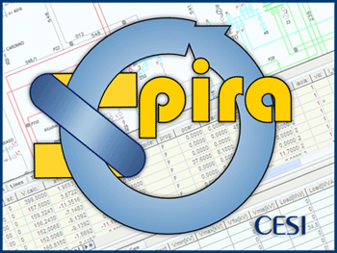

CESI presentation
See. 6.5.1

Tool description
SPIRA (Integrated system for the planning of HV transmission networks) is an advanced computing system (on Windows platforms) for the planning of HV transmission networks that:
- includes both optimisation and power analysis computing models developed by CESI and applied since many years in several electric system studies carried out both on Italian and foreign Country networks
- constitutes an interactive graphic system to manage digital programs utilised in the search of optimum strategies of short/long term expansion of HV networks
- allows one line schematic and-geographic diagrams of the network under consideration to be created by assuring formal coherence between the network topology and alpha-numerica the electrical parameters relevant to its components and graphic functions.
- allows the creation, up-dating and queries of the data base with the electrical parameters of the network to be studied being managed, by means of specific menus and forms.

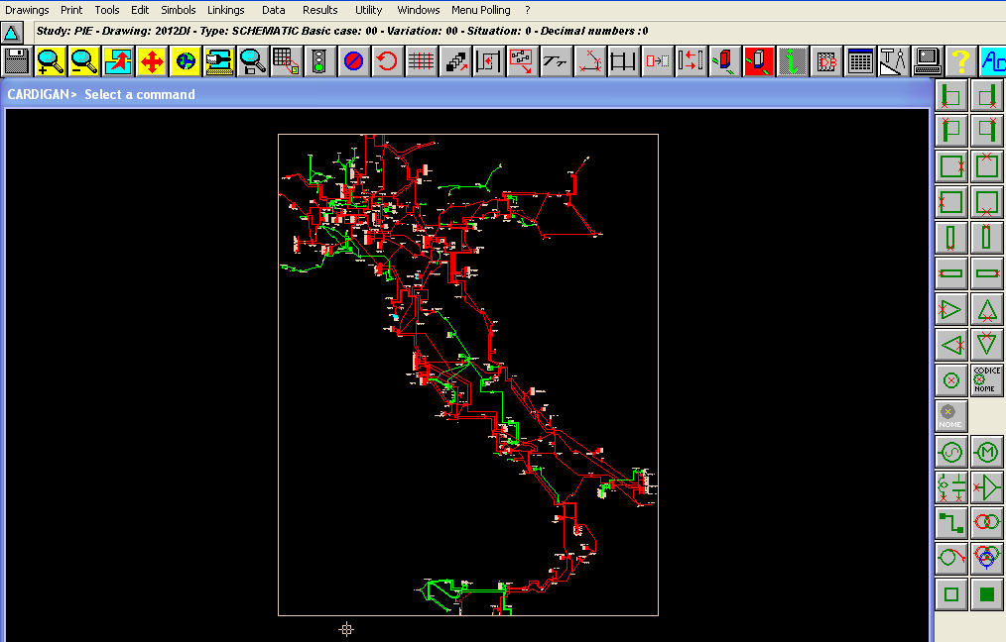

Computation Program
The various technical-economical facets are analyzed by means of specific computation programs that take parameters mostly affecting the investigated problem into due account.
- FLOWAC: for checking the a.c. load flow under normal operating conditions and with automatically-selected contingencies of network components (lines and transformers)
- CTINEW: for defining short circuit current levels at network nodes
- SIPARIO: For defining active and reactive optimisation (OPF) of the network with different objective functions
- GRARE: For adequacy analysis of transmission network with probabilistic and deterministic approach
The SPIRA system, moreover, allows specific network problems to be analyzed by means of specialistic computation programs such as:
- EQSTAR for the evaluation of network equivalents, or parts thereof, to be used in a.c. load flows and network adequacy probabilistic analysis computations
- EQUI for the evaluation of network equivalents, or parts thereof, when calculating short circuit currents
- DIFOAR for the appraisal of “flicker” disturbance caused by open arc furnaces at the various network nodes
- CORARM for investigating harmonics propagation into network in the presence of disturbing loads

Key Features
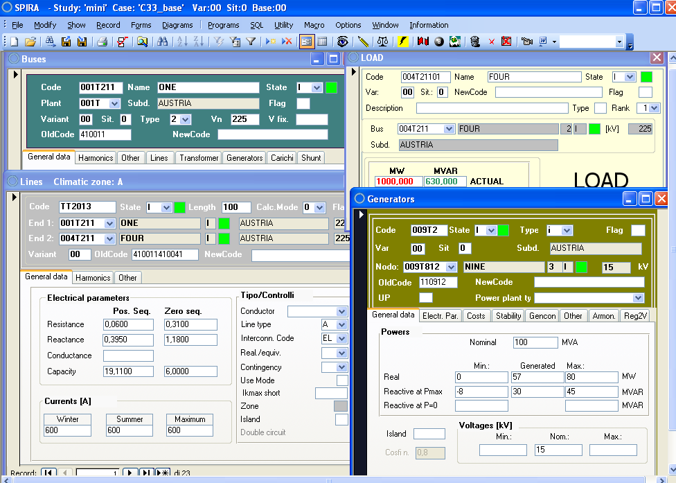
The graphic man/machine interface (MMI) of the system enables :
- the network to be managed in a graphic mode
- external data bases to be activated
- computation programs to be activated
- active processes to be handled
- the data base to be queried and modified
- study results to be managed
- peripherals to be managed
- utility programs to be handled
CARDIGAN is the CAD interface enabling all graphic functions to be carried out that are needed for creating the network schemes
STUDY DB constitutes the data base of the network electric parameters that is shared by all applicative computation programs and holds the results of computations carried out by these applicative programs.
The access, gained through special menus and masks as well as by means of the graphic interface, enables variants to be introduced on the investigated network for a rapid check about possible network alternatives.
The STUDY DB data base, moreover, provides the user with a set of default parameters for such components as lines and transformers to be predominantly used in the planning stage when accurate parameters are still unavailable.
Thanks to the graphic interface, it is possible to create the network scheme layout.
Drawing set-up as well as modifications thereof are made easier by several graphic functions that can be activated by means of icons on the screen.
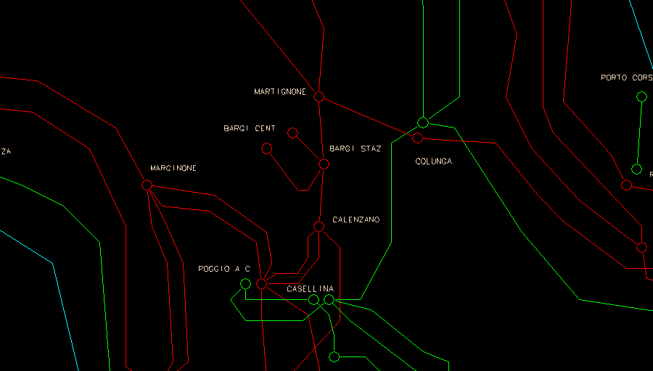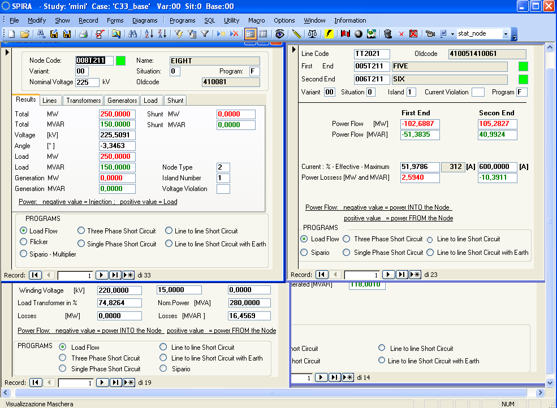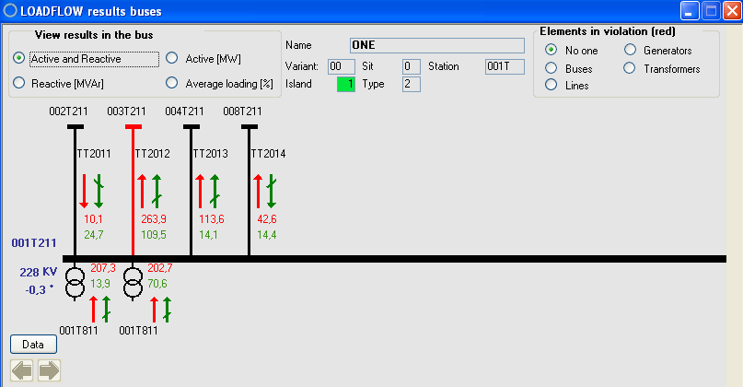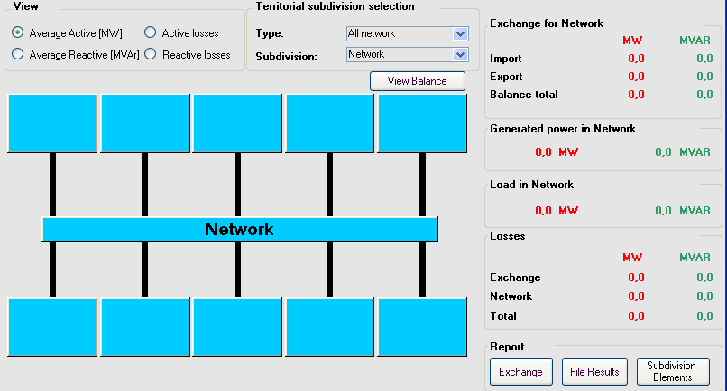
Besides, when drawing a network scheme layout, access can be gained to the data base for the automatic introduction of topologic-type alphameric information.
The results of studies that are more frequently carried out (load flow, short circuit current evaluations) can be displayed on the screen and on paper, but also on the network scheme in order to facilitate its analysis.
Graphic functions also enable the most interesting network sections to be selected for a graphic presentation of results that are to be included in study

Modularity and open-ended layout to other computation system
The SPIRA system features a modular structure enabling personalized versions to be made ready by embodying computation programs as needed to a customer’s specific requirements.
An overall open-ended layout to other computation systems is made easier by special interface programs for data exchange in order to facilitate the preparation of data files in a SPIRA environment.
Communication interfaces to other computation systems also make it possible to perform other types of studies about electrical systems. As an example, it is possible, by means of the SICRE simulator, to analyze the short-term and long-term system dynamics by taking into account, with the help of detailed models, the behaviour of control and protection equipment operating on the system itself at local, regional or national levels.

Other tools linked to SPIRA
No other projects related to.

Expected CIM functionalities
At the beginning of 2010 CESI starts to support the development of internationally unified data definition and data exchange mechanisms and is therefore committed to integrate and continuously update SPIRA in order to cover ENTSO-E needs and rules regarding the reliability of load-flow and short circuits results. Up to now the software is under development in order to be compliant with the models (rev1. and rev 2) used during the IOP tests.
CESI will continue supporting the development of CIM related standards and the innovations supplied with next releases.

SYNDIS

Vendor presentation
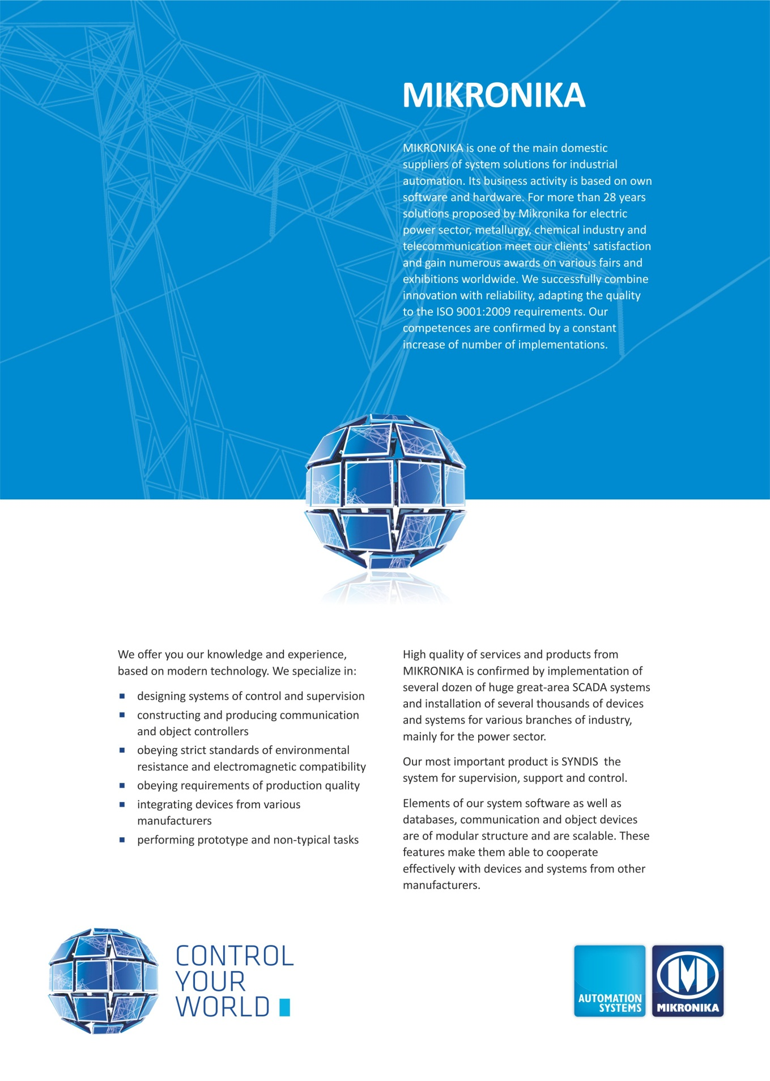

Tool description
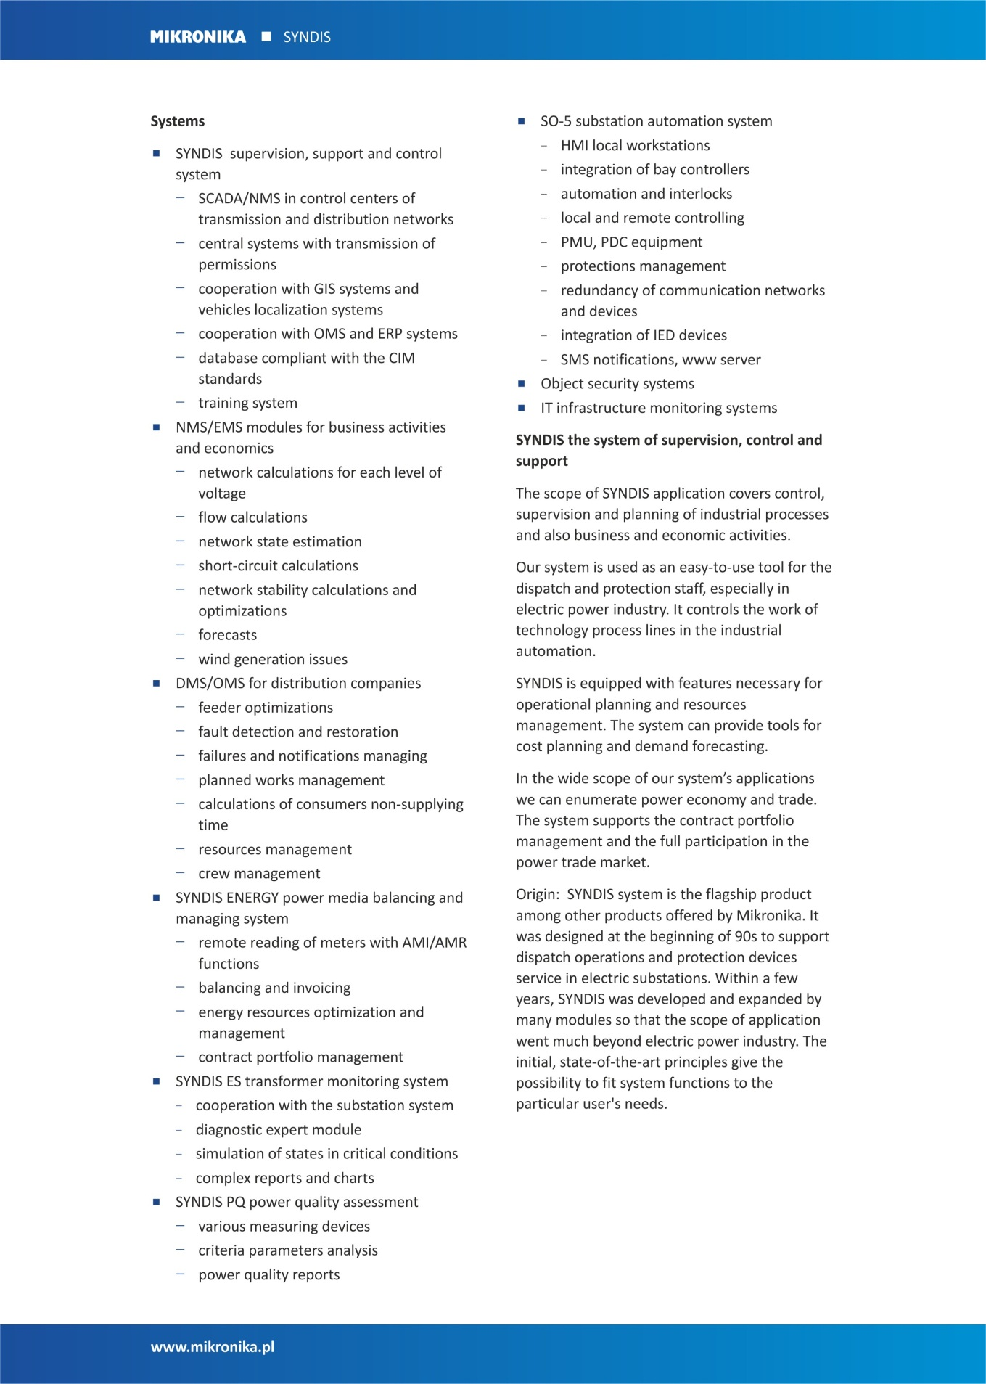
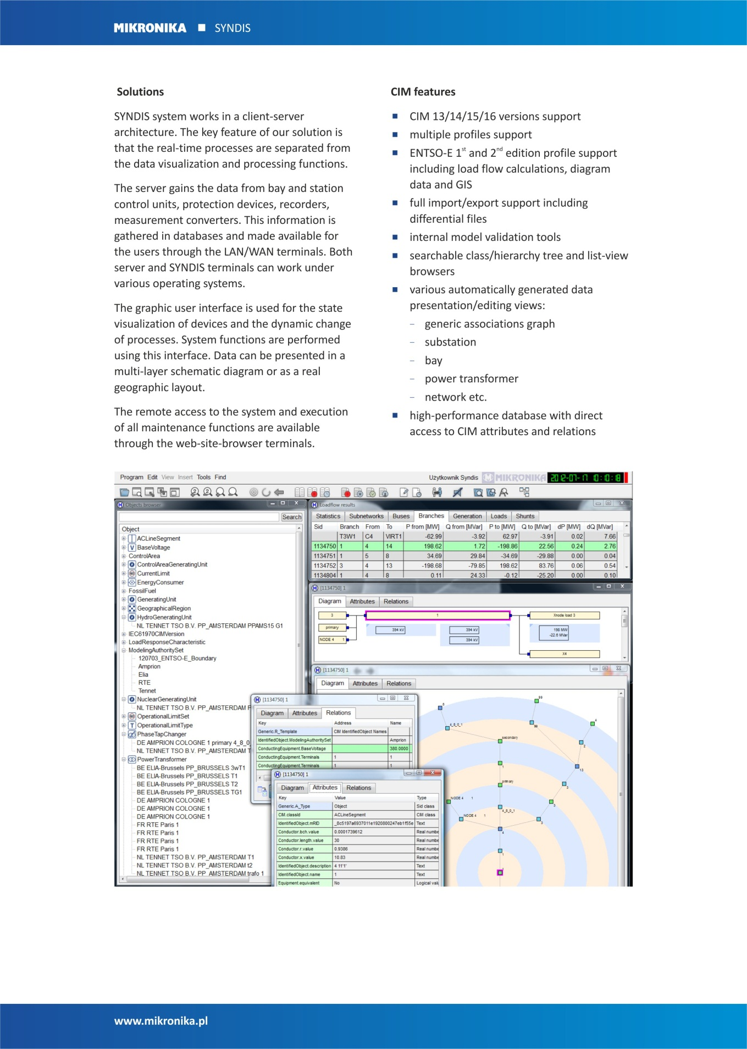

TNA

Vendor presentation
"DMS Group" LLC Novi Sad  Sremska 4  21000 Novi Sad, Serbia  www.dmsgroup.rs | Electricity Coordinating Center Ltd.  PO Box 50  11040 Belgrade 33, Serbia  www.ekc-ltd.com
DMS GROUP Ltd. is the private software engineering company for research, development and software engineering in electrical power systems, specially devoted to Distribution Management Systems (DMS), but also experienced in Energy Management Systems (EMS) and Energy Market Management (EMM).
- DMS Group, supported by a large team of expert engineers and development staff, provides services in development as well as in tender/proposal phase, installation, engineering, commissioning, and training for system use. Our team has proved itself extremely efficient in system customization according to customers' requirements. Expert resources of DMS Group, besides exceptional qualification, motivation and working discipline also have a very competitive price. DMS Group has numerous installations of DMS software worldwide.
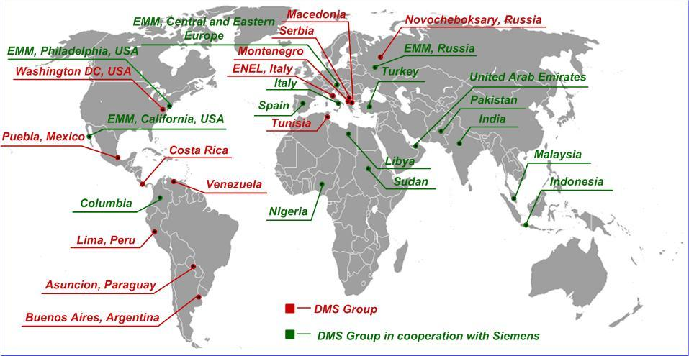

Electricity Coordinating Center (EKC) Belgrade provides consulting and software services in the area of electric power systems, transmission and distribution systems and power generation. It is consulting company with great experience and well-known and recognized in Continental Europe, especially in South Eastern and Central Eastern Europe, as well as in the Middle East and Central Asia. It provides a full range of incorporated strategic advisory services, technical consultancy, developing state-of-art solutions, models and methodologies in the energy sector. Its services and tools are based on obligation to provide neutral, objective and expert advices that can guide clients to success.
EKC employs highly skilled and experienced staff, all of them fluent in English and other languages too (German, French, Russian…), educated and trained to fulfil any task given. Its employees have a solid reputation for delivering high quality services on time, even under time pressure. Together with its partners and outside experts worldwide, EKC can resolve any problem and give solutions that will lead its clients to successes.
EKC’s experts use worldwide known professional software tools (PSSE™, GTMax, WASP…) and also, application software developed by its own experts. At the beginning, these tools have been developed for internal purposes, in order to speed-up and improve quality of work and results. After successfully usage of the software on several projects these software tools are used wide in the SEE region and Europe as well.
Also, it provides technical know-how for the development of professional software covering different fields of TSOs and electricity market operation.
In addition to consultant services, EKC also share its knowledge through organizing educational and professional trainings through EKC’s special department for Education.

DMS and EKC have a lengthy cooperation in a field of software solutions for TSOs.
- Merlin Conversion & Merging Utility Software:
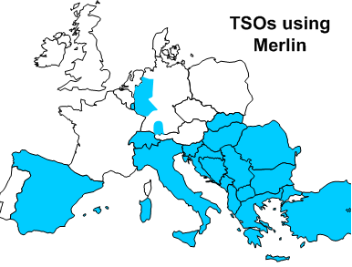 | Merlin CMU is a software used by more than half TSOs of the Continental Europe (and by ENTSO-E (UCTE) secretariat), for two-directional conversion between UCT and PTI RAW data formats as well as for validation and merging the UCT/PTI datasets. Merlin is officially recommended by UCTE Secretariat (2007) for standard usage. It was also used as official converter in the UCTE–IPS/UPS (former SSSR) connection project.

- PSA software for DACF, NTC and PTDF/MF:
Our Load-flow tool Power System Analyzer is widely used in SEE region for DACF, NTC and PTDF/MF calculations. As a standard DACF load flow software PSA is used by the TSOs of Serbia and Albania, as well as for offline DACF analyses by the TSOs of Montenegro, Macedonia and Bosnia-Herzegovina.

- CEE CAO IT Freising/TPC Tool:
The highlight project where we are involved is the provision of complete IT support for CEE CAO Freising (coordinating the capacity auctions for the TSOs of Austria, Czech Republic, Slovenia, Hungary, Poland, Slovakia and two TSOs from Germany). Our role is to provide tools for:
- merging & data adjustment (data validation, data replacements, total exchanges-adjustment,) of network models and other data for D/M/Y coordinated flow-based auctions. There the automatic validation, replacements, adjustment and merging of 24 hours models for the whole Europe is performed in an automatic sequence
- the Load Flow tool for standard load flow operations (AC and DC load flow, contingency analyses, scaling, OTDF, etc) and for PTDF/MF calculation

- TNA software:
Transmission Network Analyzer is a Standalone Tool developed jointly by EKC and DMS group, for SEE TSOs, and recently also used in CEE region. TNA software comprises the experience of previous software, and is provided for load flow, PTDF/MaxFlow, models validation/ fixing/ merging, UCT-CIM conversion and short circuit analyses.

Tool description
TNA – Transmission Network Analyzer (hereinafter: TNA Application) represents the entire application for design, calculation and analysis of electricity transmission networks. The Application is focused on the functionality development used for the purposes of setting the network models, analyses of transmission network and calculation of transfer capacities, as segments of procedures related to the open electricity market.
TNA is standalone application intended for working on a single computer. As for architecture, it is realized as a server – client set to operate on a single computer. In the further development, depending on clients’ needs, it is possible to make a classification into server and client part. The Application was created on the basis of mutual efforts made by DMS Group Novi Sad and EKC Belgrade.
The Transmission Network Analyzer (TNA) main functions are:

- Validating, fixing and merging of the network models,
- static load flow calculations and related contingency and sensitivity analyses,
- Technical Parameters Calculation - PTDF/MF calculation, according to the Flow-based Coordinated Auctions principles in the regions of SEE and CEE,
- Short-circuit analyses,
- Various types of conversion (CIM XML – UCT, CIM XML – RAW, UCT- RAW) in both directions.

It supports working with UCT and CIM XML formats.
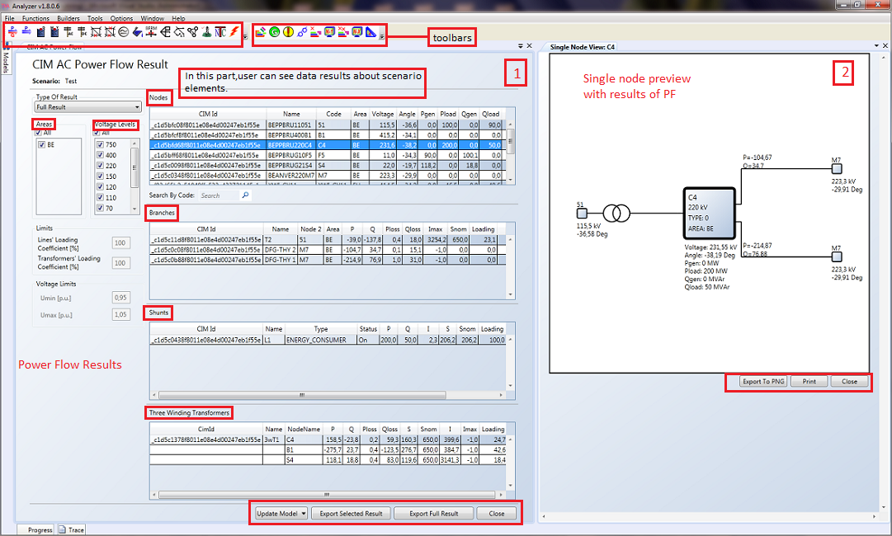
Figure 1 – TNA Load Flow Results with Single Node View
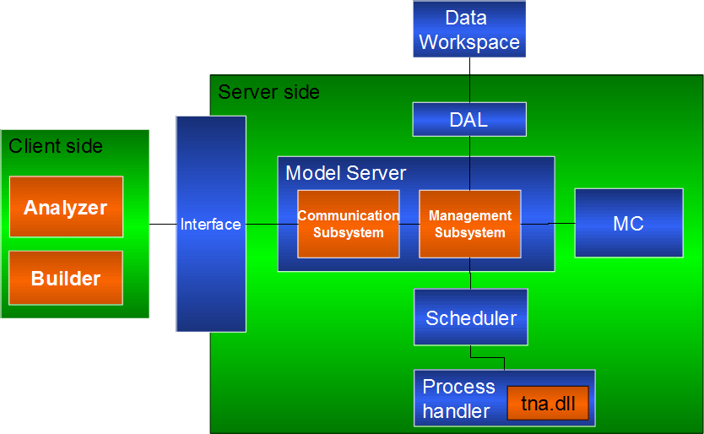
Figure 2 – TNA Architecture

The TNA Application contains four components:
- Builder (client).
- Analyzer (client).
- Actualizer (server).
- Data Workspace.

Server-client architecture is used in the creation of the TNA Application. Server application is represented by the Actualizer responsible for running of all calculations and communication between client and server, as well as direct communication between clients and Data Workspace module.
The client side is represented by Analyzer and Builder applications.
In the creation of the TNA Application, .NET technology is used with the associated .NET 3.5sp1 Framework. The clients are entirely written in WRF, server side is written in C# and C++. The libraries of power functions are written in C++ in order to obtain maximum efficiency of the calculation. The communication between the client and server is realized by using the WCF technology.
TNA – Functional units in the software
The TNA Application is functionally composed of three functional components:
- Builder,
- Functions,
- TNA tools
- CIMedy Tools

Builder component enables forming, modification and saving of scenarios (list of input data and results of functions), as well as running of the existing scenarios of models of transmission networks with associated types of files: UCT, CBCO, BCE, AATR, AANT, GSK and TSO. Also, a single manual or automatic validation of entered files is enabled.
Builder is also used for design and modification of OTDF, N-1, N-X Contingency & Monitoring lists, CBCO lists, as well as for modification of the existing UCT files. Builders are written in C# by applying MS WPF and WCF technologies.
Functions represent a group of applications intended for offline (planning) analysis of transmission networks. The following main groups of functions are comprised in TNA:
- AC/DC Load Flow.
- Maxflow-related functions: PTDF/MF, BFRM …
- Post Auction Contingency Analysis
- OTDF
- N-1 and N-x contingency analyses
- Net Transfer Capacity (NTC) calculation
- Short Circuit calculation
TNA Tools is a group of tools used for validation of input models, connection of national transmission networks and generation of reports on occurring problems.
- Model Tool is used for validation, verification of convergence and merging of UCT models of transmission network.
- CBCO Tool is used for validation of CBCO lists that are the input for PTDF/MaxFlow calculation.
- CIM Tool is used for conversion between CIM and UCT models.
- CIMedy tool is a tool for viewing and manipulating with CIM models. It allows edit, create and delete elements from CIM models with nice and intuitive display.
Five main views are:
- CIM view - insight into all elements based on CIM design
- Power view - elements filtered by geographical location and substations
- Graphical view - draws graphical presentation of substations with closest neighbours
- Diagram view - draws diagrams with ability to change and elements positions
- Slack selection - allows manual selection of slack node for Load Flow and Fault calculation
In following picture there is a window with line segment view. It is possible to see all characteristics of each element using this CIMedy tool.
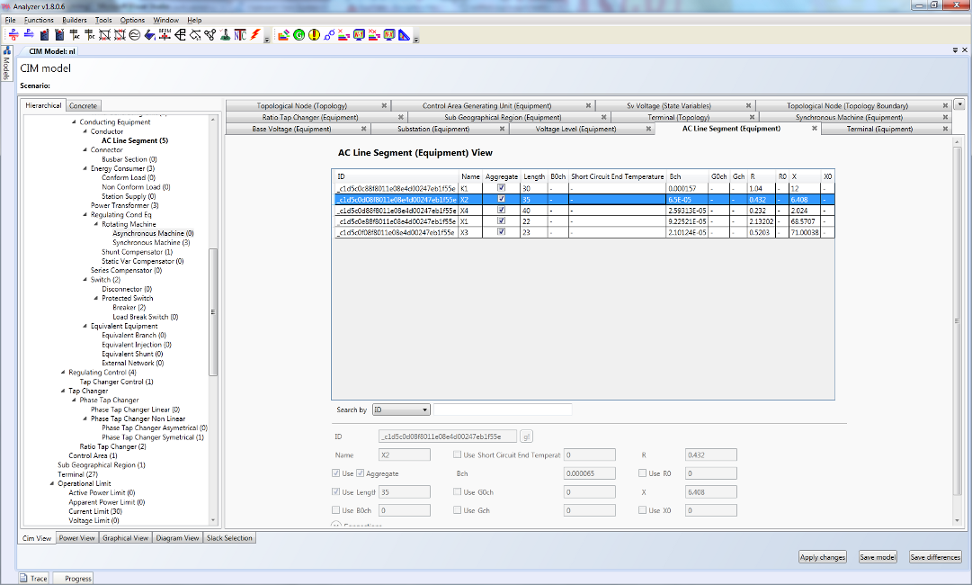
Figure 3 – CIMedy Tool (Line segment preview)
In the picture below, there is a picture of graphical view for one single substation.
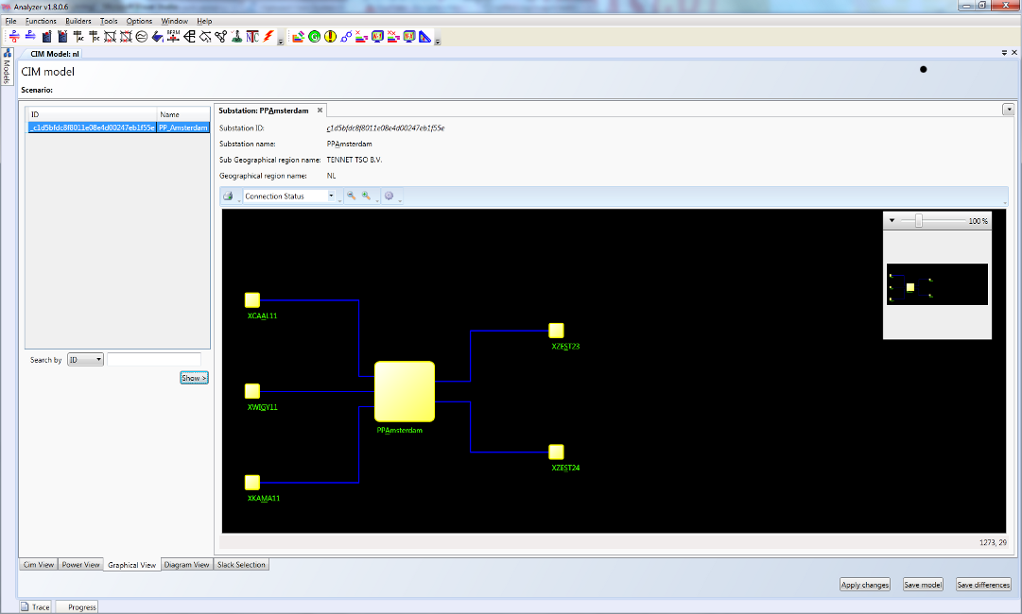
Figure 4 – CIMedy Tool (Graphical view of single node)

Expected CIM functionalities
- Transmission Network Analyzer supports functions for Transmission Networks. Currently Transmission Network Analyzer supports different functions for UCT models for example: Load Flow, PTDF, OTDF, Contingency Analysis, Area Interchange, NTC....; On the other side, currently TNA supports Load Flow and Fault Calculation for EntsoE CIM profiles (Profile1-CIM14 and Profile2 CIM16).
- TNA works with different models and it supports conversion from one model to another. TNA imports and exports CIM models, it is accurate in all calculations. Also there is possibility of merging two models in one new model.
3) Graphical view of results is simple and comprehensive. It is possible to see single substation with neighbourhood view. If application uses XML, then it is possible to see diagram view.
4) TNA Application does import and export CIM models that can be zipped/unzipped.
5) TNA Application does convert XML files into UCT, RAW in both directions.
In the future further development power market functions, new functionalities based on fault calculation and support of dynamic simulations are expected. Implementation of full database support is also in plan. There is also a plan to develop all functions that work with UCT for now, for CIM models.

UIB Adapter for use with the OSIsoft PI System

Vendor presentation
SISCO (Systems Integration Specialists Company, Inc.) is a privately held company founded in 1983 and based in Michigan USA with resellers and OEM partners across the globe. SISCO is the global leader in standards-based communications and integration technologies for electric utilities, manufacturing and automation industries. SISCO software is used in a wide variety of applications from electrical power transmission, distribution and generation systems to manufacturing and postal automation equipment. SISCO works with all major OEMs by helping lower their cost to incorporate open standards enabling interoperable systems and lowering the cost to users. SISCO helps users with off-the-shelf connectors and adapters that leverage mainstream networking and middleware technology with support for electric utility industry standards like CIM, ICCP-TASE.2, IEC 61850, and other open international standards. SISCO has a proven track record of working effectively with OEMs and integrators that have contributed to the success of standards based solutions in the industries we serve. Working with SISCO allows our integrator partners to deliver more capabilities to our joint customers at a lower total cost of ownership and with lower technical risk. End users working with SISCO are assured that they have chosen a reliable supplier that can be counted on to work effectively with their suppliers to deliver a working solution.
Corporate Headquarters: 6605 19 1/2 Mile Road, Sterling Heights, MI 48314-1408, USA
Main Telephone Number: +1-586-254-0020
Main Fax Number: +1-586-254-0053
E-Mail: info@sisconet.com
Website: http://www.sisconet.com

Tool description
SISCO’s Utility Integration Bus (UIB) adapter for use with the PI System (PI) from OSIsoft combines the power of the OSIsoft world-leading platform for real-time performance management with the application integration and common information exchange model capabilities of SISCO's UIB. The SISCO UIB PI Adapter receives modelling information, such as a network connectivity model typically maintained by a network modelling tool, EMS,DMS, or GIS system; and automatically configures the PI Analysis Framework (AF) for those points that are being historized by the PI Server. The SISCO UIB PI Adapter organizes the PI tags within the context of models familiar to the user such as IEC’s Common Information Model (CIM), existing models from other applications like GIS or EMS, or a user-defined power system model. Changes made to the connectivity model are delivered via the UIB to the SISCO UIB PI Adapter, which automatically creates the PI AF entries, and PI configuration needed. The UIB and PI System provide a unique cost saving solution for electric utility users that minimizes manual reconfiguration.
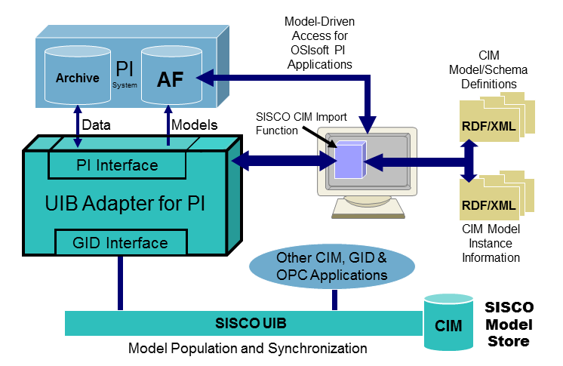
Block Diagram of SISCO UIB Adapter for OSIsoft PI System
Features
- Works with customer defined models, models derived from applications, or industry standard models such as CIM, IEC61850, ISA, etc.
- Imports model definitions and network connectivity information into PI AF to enable PI applications with access to the CIM.
- Supports IEC CIM imports and procedures for:
  - Schema creation through the merging of CIM profile files.
  - Full model imports
  - Incremental Model Imports
  - Merging of Model Instance files through the use of Model Authorities and CIM Model File Headers
  - Built in validation of instance files versus schema/profiles.
- Supports model synchronization between the PI and the power system models in other systems to enable historization of these external model changes within the PI environment.
- Provides a Model Explorer interface that allows users to browse and edit the resulting models using a CIM context.

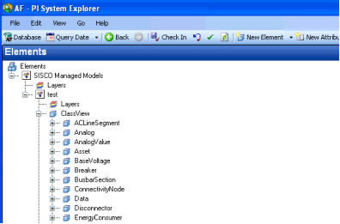
Screen Shot Illustrating Result of CIM Import in PI-AF
An additional capability, not tested at this IOP, is that the PI Adpater can auto-create PI tag names based upon the model definitions as well as integration with Enterprise Service Bus (ESB) technology for imports. This ESB capability also allows PI System information to be exposed to other applications, attached to the ESB, through the SISCO Utility Integration Bus layer.
For a complete data sheet, see: http://www.sisconet.com/downloads/MKTLit_UIB_PI.pdf

Handling. Other tools linked to the UIB Adapter for use with the OSIsoft PI System
The product is part of a family of products that integrate together through the SISCO Utility Integration Bus (UIB). The UIB provides application adapters, and programmatic interfaces, based upon the CIM based Generic Interface Definition (GID) abstract service definitions in the IEC 61970-40X standards. Through the proper deployment/integration of the UIB products, real-time data can be exchanged within the context of the CIM model over ESB and other SOA middleware systems using JMS such as IBM WebSphere, Tibco, Oracle, etc.
For more detailed information, see the following link: http://www.sisconet.com/uib.htm

Expected CIM functionalities
The adapter is a core product component from which other products/systems can be created. Its flexibility allows it to be used as a basis to:
- Send/Receive IEC 61968 CIM messages
- Model-driven Condition Based Maintenance Applications
- Wide Area protection schemes
- Synchrophasor processing applications
- User custom applications

Utility Integration Bus (UIB) SISCO Model Store (SMS)

Vendor presentation
SISCO (Systems Integration Specialists Company, Inc.) is a privately held company founded in 1983 and based in Michigan USA with resellers and OEM partners across the globe. SISCO is the global leader in standards-based communications and integration technologies for electric utilities, manufacturing and automation industries. SISCO software is used in a wide variety of applications from electrical power transmission, distribution and generation systems to manufacturing and postal automation equipment. SISCO works with all major OEMs by helping lower their cost to incorporate open standards enabling interoperable systems and lowering the cost to users. SISCO helps users with off-the-shelf connectors and adapters that leverage mainstream networking and middleware technology with support for electric utility industry standards like CIM, ICCP-TASE.2, IEC 61850, and other open international standards. SISCO has a proven track record of working effectively with OEMs and integrators that have contributed to the success of standards based solutions in the industries we serve. Working with SISCO allows our integrator partners to deliver more capabilities to our joint customers at a lower total cost of ownership and with lower technical risk. End users working with SISCO are assured that they have chosen a reliable supplier that can be counted on to work effectively with their suppliers to deliver a working solution.
Corporate Headquarters: 6605 19 1/2 Mile Road, Sterling Heights, MI 48314-1408, USA
Main Telephone Number: +1-586-254-0020
Main Fax Number: +1-586-254-0053
E-Mail: info@sisconet.com
Website: http://www.sisconet.com

Tool description
The SISCO Model Store (SMS) for the Utility Integration Bus (UIB) provides a model repository for UIB applications that supports an environment in which a common data exchange model for application integration can be stored and distributed across an enterprise service bus. Data stored in legacy applications are normally represented using proprietary methods that are unique to each application. Any external application that needs this data must either be programmed to understand these proprietary conventions or must use data transformation tools that transform the data for each application-to-application data path that exists in the system. As the system changes over time due to new data points being added, data moving from one application to another, or new applications being added, each individual data transformation mapping must be continuously maintained to reflect the changes in the underlying application data representations. With the common model-driven approach supported by SISCO’s UIB, applications exchange data in the context of a unified model (e.g. CIM via IEC 61970 and IEC 61968) that hides the details of how data is stored internally in each application. The use of CIM as a common model allows data from multiple applications to be merged into a unified enterprise level view of data. Even if the model changes, as long as the relationships between objects in the model remain consistent, applications can still find the data they need by examining the model. Users benefit because they no longer need to maintain proprietary arcane tag naming conventions and separate transformations for each application-to-application data path. And, by using the standardized CIM for data exchange users have access to off-the-shelf applications instead of having to write their own or pay vendors to customize their applications to accommodate proprietary data conventions. A block diagram of the UIB architecture is shown below. Only the elements in blue were tested at this IOP.
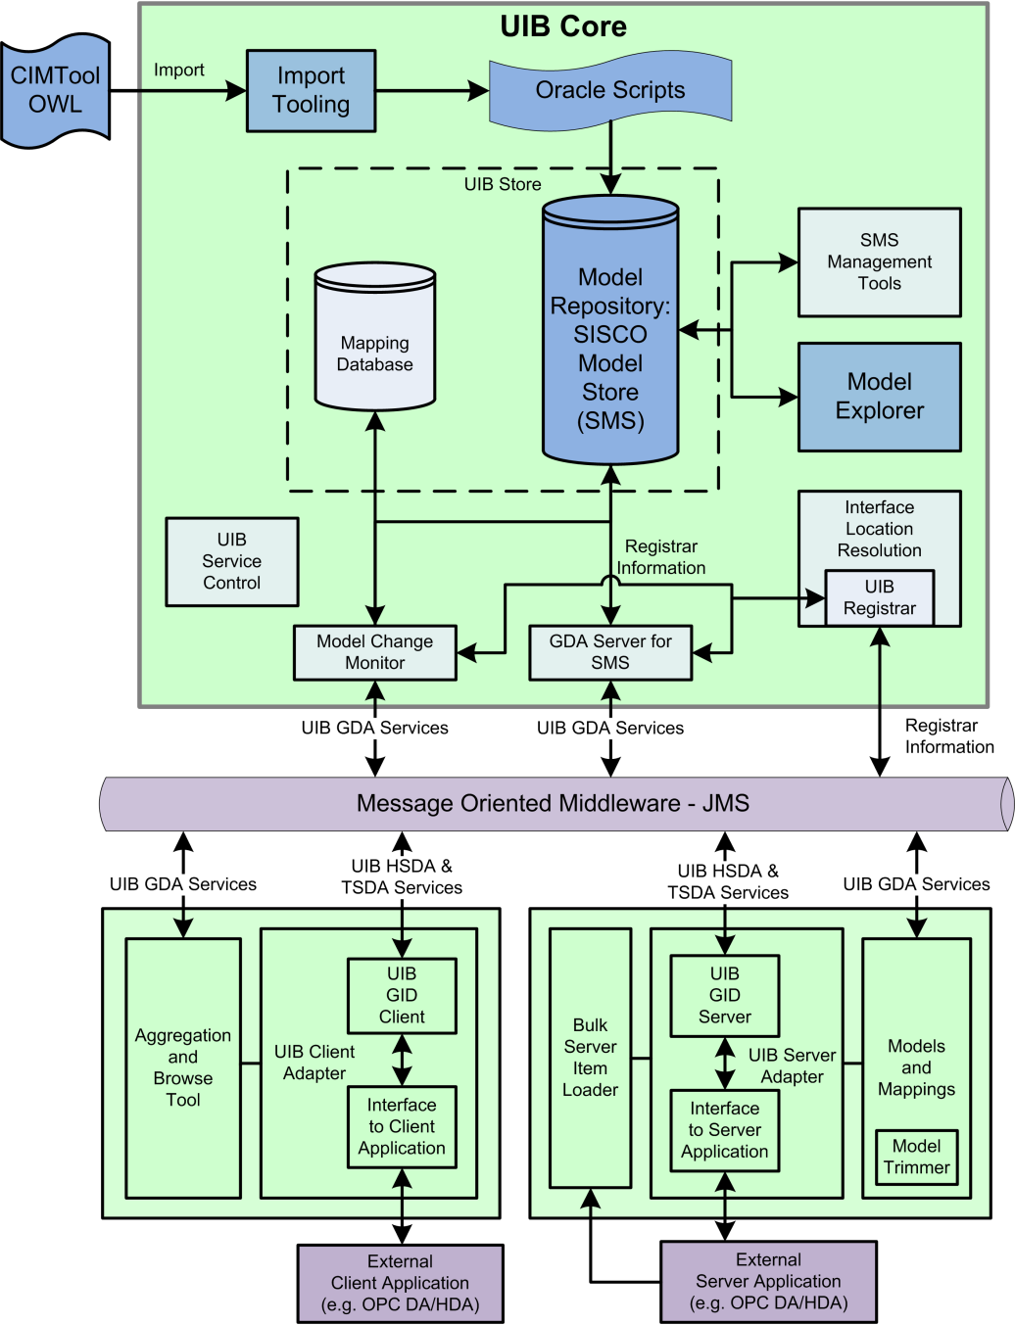
Block Diagram of SISCO UIB SISCO Model Store (Blue Components Tested)
Features
- Supports a common data exchange model based on CIM for application integration over an ESB supporting JMS.
- Provides Location Independence – Applications access data in context of the model
- Enables distribution of model information and automation of model updates
- Standardized interface services comply with the abstract definitions of the IEC 61970-40X Generic Interface Definition (GID)
  - Generic Data Access (GDA ) for model access and management.
  - High Speed Data Access (HSDA) for real-time data access
  - Time Series Data Access (TSDA) for access to historical data
- Common data exchange model minimizes data transformations and provides global context for information.
- Supports off-the-shelf adapters for OPC Data Access (DA) and Historical Data Access (HDA).
- Enables merging of application data to create unified views of utility operations.
- Eliminates application specific dependencies that isolate integration adapters from changes in other system components.
- Reduces integration configuration by enabling application adapters to discover data without requiring knowledge of each data source.
- Model neutral design uses schema file for configuration enabling off-the-shelf support for custom CIM profiles and support for other standards like ISA S.95 and ISO 15926.
For a complete data sheet, see: http://www.sisconet.com/downloads/uib.htm

Handling. Other tools linked to the UIB SISCO Model Store (SMS)
The product is part of a family of products that integrate together through the SISCO Utility Integration Bus (UIB). The UIB provides application adapters, and programmatic interfaces, based upon the CIM based Generic Interface Definition (GID) abstract service definitions in the IEC 61970-40X standards. Through the proper deployment/integration of the UIB products, real-time data can be exchanged within the context of the CIM model over ESB and other SOA middleware systems using JMS such as IBM WebSphere, Tibco, Oracle, etc.
For more detailed information, see the following link: http://www.sisconet.com/uib.htm

Expected CIM functionalities
The SISCO SMS for the UIB is a core product component of the UIB from which other products/systems can be integrated.
- Import CIM files per the latest Interop tested profiles for both IEC 61970 and IEC 61968.
- View class and instance information via a Java based model explorer.
- Supports model discovery, data access, and model management services over JMS using a CIM model for data exchange that is stored in the SMS.
- Model notification messages can be generated to keep applications updated as CIM model is updated in the SMS.

