|  |  |  |  |  |
| --- | --- | --- | --- | --- |
| Joint operation between the Western and Eastern Danish subsystems on DC Link Great Belt | | | | |
| Appendix 8 to SOA Annex OS (DK1 and DK2) | | | | |
|  | | | | |
|  | | | | |
|  | | | | |
|  | | | | |
| [http://www.fingrid.fi/_layouts/Fingrid.Internet/images/logo.png](http://www.fingrid.fi/en/) | C:\Users\tsk\AppData\Local\Microsoft\Windows\INetCache\Content.Word\Energinet_primaer_RGB.JPG |  |  | Ein Bild, das ClipArt enthält.  Automatisch generierte Beschreibung | |

|  |  |  |
| --- | --- | --- |
| ****Approval date**** | ****Entry into force**** | ****Revision**** |
| **2022-06-22** | **2022-06-22** | **Initial version based on old SOA** |
|  |  |  |
|  |  |  |
|  |  |  |
|  |  |  |
|  |  |  |
|  |  |  |

Table of contents

[1 Background 3](#_Toc105769937)

[2 Transmission facilities linking the subsystems of Eastern Denmark and Western Denmark 3](#_Toc105769938)

[3 Electrical safety for facilities 3](#_Toc105769939)

[3.1 General 3](#_Toc105769940)

[3.2 Responsibility for electrical operation/Operational management 3](#_Toc105769941)

[3.3 Switching responsible operator 3](#_Toc105769942)

[3.4 Operational monitoring and control in respect of electrical safety 4](#_Toc105769943)

[3.5 Switching schedule 4](#_Toc105769944)

[3.6 Disturbance management 4](#_Toc105769945)

[3.6.1 Cross-border link trips – management 4](#_Toc105769946)

[3.6.2 Switching schedule 4](#_Toc105769947)

[3.6.3 Fault finding 4](#_Toc105769948)

[3.6.4 Fault clearance, remaining faults 4](#_Toc105769949)

[4 System operation for facilities under 2 4](#_Toc105769950)

[4.1 Total Transmission capacity 4](#_Toc105769951)

[4.2 Routines for determining the transmission capacity 5](#_Toc105769952)

[4.3 Trading Capacity (NTC) 5](#_Toc105769953)

[4.4 Operational monitoring and control in respect of system operation 5](#_Toc105769954)

[4.4.1 Regulating the link 5](#_Toc105769955)

[4.5 Outage planning 5](#_Toc105769956)

[4.6 System protection - emergency power - stopping of ramping 6](#_Toc105769957)

[4.6.1 General 6](#_Toc105769958)

[4.6.2 Delta Power Control (DPC 1-4) 6](#_Toc105769959)

[4.6.3 Stopping of ramping 6](#_Toc105769960)

[4.6.4 Emergency power 6](#_Toc105769961)

[4.6.5 System protection schemes 6](#_Toc105769962)

[5 System services 7](#_Toc105769963)

[5.1.1 Manual reserves 7](#_Toc105769964)

[5.1.2 Manual frequency support 7](#_Toc105769965)

[5.1.3 Automatic frequency support 7](#_Toc105769966)

[5.1.4 Transmission scope for operational reserves 7](#_Toc105769967)

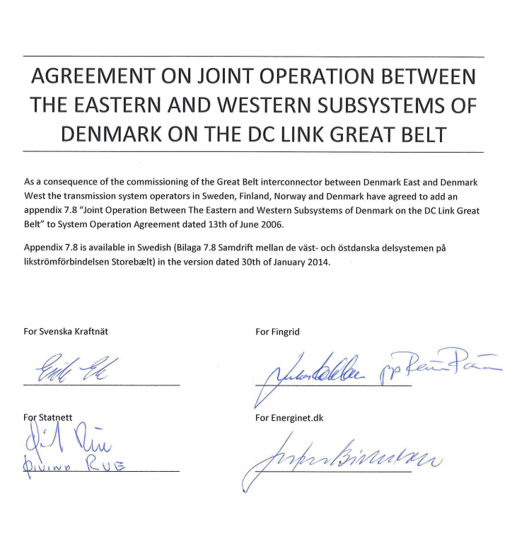

**Revision history**

|  |  |  |
| --- | --- | --- |
| **Version** | **Date** | **Comments** |
| 1. Final | 2014-01-30 | First version. |

# Background

The subsystems of Norway, Sweden, Finland and Eastern Denmark are synchronously interconnected. The subsystem of Western Denmark is connected to Norway, Sweden and Eastern Denmark using DC links. This Appendix describes the conditions for the operation of the DC link between Western and Eastern Denmark linking the synchronous systems in the Nordic area and Continental Europe.

# Transmission facilities linking the subsystems of Eastern Denmark and Western Denmark

**Facility Voltage kV**

Great Belt

Fraugde - Herslev 400 kV DC

It is decided on a weekly basis whether the settlement takes place in Fraugde or Herslev.

# Electrical safety for facilities

## General

The common ground for the electrical safety work of the system operator companies within ENTSO-E Regional Group Nordic is constituted by the European standard for managing electrical high-voltage facilities EN 50 110 which governs the organisation and working methods. In addition to the standard, there are national regulations and special instructions which entail certain mutual differences between the system operators as regards dealing with operational issues from an electrical safety point of view.

## Responsibility for electrical operation/Operational management

Energinet is responsible for the electrical operation of Great Belt.

## Switching responsible operator

Energinet is the switching responsible operator for the whole of Great Belt.

## Operational monitoring and control in respect of electrical safety

Operational monitoring and control of the DC link are carried out from Energinet’s Control Centre at Erritsø.

## Switching schedule

Switching concerning Great Belt takes place as follows:

* Switching which concerns Great Belt takes place in accordance with a switching schedule drawn up by Energinet.

## Disturbance management

### Cross-border link trips – management

During operational disturbances, measures in accordance with issued instructions shall, as soon as possible, restore the link to normal state.

### Switching schedule

Energinet draws up switching schedules for switching concerning Great Belt.

### Fault finding

Initial fault finding is carried out differently from case to case. Energinet is responsible for fault finding. For fault finding, a special preparedness plan for submarine cables has been drawn up.

### Fault clearance, remaining faults

Energinet is responsible for fault clearance. For fault clearance, a special preparedness plan for submarine cables has been drawn up.

# System operation for facilities under 2

## Total Transmission capacity (TTC)

The total transmission capacity (TTC) of the link is dependent on the temperature of the air and the earth.

Nominal capacity: 600 MW

Technical minimum capacity: 18 MW

## Routines for determining the transmission capacity

Energinet determines the transmission capacity between Western Denmark and Eastern Denmark. In the case of intact connecting networks, the transmission capacity is determined by the thermal capacity of the facilities’ components. The thermal overload capability allowed by monitoring equipment shall be capable of being used as and when required in accordance with special instructions.

## Trading Capacity (Net Transmission Capacity - NTC)

The normal trading capacity is:

590 MW from Western Denmark à Eastern Denmark

600 MW from Eastern Denmark à Western Denmark

The following calendar day’s trading capacity is set every day. The trading capacity can be limited by line work in the connection area, production in the connection area, overhauls on the link etc.

## Operational monitoring and control in respect of system operation

Operational monitoring and control are carried out from Energinet’s Control Centre at Erritsø.

### Regulating the link

Regulation of Great Belt in accordance with agreed exchange plans is carried out from Energinet’s Control Centre at Erritsø.

Regulation takes place, in principle, in accordance with a power plan using ramping transitions between different power levels. The plans are issued as power plans in full MWs for each 5 min plan value. The links are regulated in accordance with this power plan linearly from power value to power value.

The power plan is determined in accordance with the exchange plan for Great Belt.

## Outage planning

Energinet shall plan outages on the link itself and in the network when the outages impact upon the transmission capacity of the link.

Overhaul planning is co-ordinated with the other HVDC links in the Nordic area.

## System protection - emergency power - stopping of ramping

### General

The Great Belt link is of major importance to Denmark, and outages due to disturbances thus generally entail major economic losses. In the event of operational disturbances, measures in accordance with issued instructions shall, as soon as possible, restore the link to normal state.

Automated operational disturbance systems are installed at Fraugde and Herslev. These can begin to function during operational disturbances in the network in Eastern or Western Denmark.

At the DC facility, system protection is installed in the form of an emergency power function and stopping of ramping function.

### Delta Power Control (DPC 1-4)

Delta power consists of control measures which are initiated manually.

Energinet’s operations centre at Erritsø has the right to initiate less than 100 MW of manual delta power on Great Bælt without advance notice. If the delta power activation is more than 100 MW, notification and approval shall take place between the staff of Energinet’s operations centre at Erritsø and SvK-VHI at Network Control at Sundbyberg.

### Stopping of ramping

Stopping of ramping represents regulating measures which are initiated automatically when the frequency in the network in Eastern or Western Denmark exceeds the established limits. Stopping of ramping is used to avoid a frequency deviation from the nominal frequency.

### Emergency power

The activation criteria for emergency power and stopping of ramping can be locally measured frequency and voltage or those measured via telecommunications on the basis of a supplied signal. In the event of activation, any ongoing normal regulation will be interrupted. Activation beyond the agreed limits and regulation back to plan can only take place following approval by and between the staff of Energinet’s operations centre at Erritsø and SvK-VHI at Network Control at Sundbyberg. (See also Appendix 5 System protection.)

### System protection schemes

System protection schemes are initiated automatically (see 4.6.4) by means of a control signal being transmitted to the converter stations by means of telecommunications.

Typically system protection schemes will utilize the Emergency power bipole control Emergency Power functionality. The activation of emergency power shall be documented retroactively and communicated to the Parties to this agreement. The reason for activation shall be given.

# System services

### Manual reserves

The purchases of manual reserves are decreased by 300 MW in Western Denmark under normal circumstances, and approximately 600 MW of manual reserves are maintained in Eastern Denmark.

In situations where the outcome from the spot market has resulted in a flow in excess of 300 MW from east to west on Great Belt, Energinet assesses whether there is a need for up to 300 MW of manual reserves in Western Denmark in the afternoon, in other words after the spot market has closed.

When Great Belt is out of operation, manual reserves are purchased to Western Denmark for dimensioning faults.

#### Intraday market

Available capacity remaining after the spot market is allocated to XBID.

### Manual frequency support

Energinet supports, as far as possible, the frequency of the Nordic synchronous system via Great Belt in the same way as via Skagerrak and Konti-Skan.

### Automatic frequency support

Great Belt is constructed for automatic power regulation. The function is used for the transmission of Frequency Restoration Reserve Automatic (FRR-A) to the Nordic synchronous system from Western Denmark.

When Konti-Skan cannot contribute to the frequency controlled disturbance reserve because Konti-Skan or the emergency power function is out of operation, Konti-Skan’s contribution to the frequency controlled disturbance reserve is placed on Great Belt.

### Transmission scope for operational reserves

Available transmission capacity can be used for the automatic or manual activation of operational reserves in accordance with this Agreement.